# Analysis of objects, pools & processes (M00804482)

## 1. List the different types of Windows objects that you can find in both memory dumps and explain them. Also, count the number of instantiations (or repetitions) for every object. (10%) //

### Infected Dump:

https://attack.mitre.org/software/S0384/

To discover how many objects are being utilised the number of handles being used must be investigated as “application must obtain an object handle, which it can use to examine or modify the system resource” (Microsoft, 2022) which will give an insight into how many objects are being used at the time the memory was captured. To initialise this calculation the first thing that must be done is to use the command in Object, pools, and processes Table 1.

|  |  |
| --- | --- |
| **Command** | **Output** |
| volatility -f ../cw2_Machine4Infected.dump --profile=WinXPSP2x86 objtypescan --output-file=objtypescan.txt | Objtypescan reveals the objects encapsulated into the memory dump, output has been supressed into |

Object, pools and processes Table 1 - objtypescan syntax

After running this command to enumerate the number of handles that are being used in memory, run the command seen in Object, pools and processes Table 2.

|  |  |
| --- | --- |
| **Command** | **Output** |
| wc –l objtypescan.txt | Wc command “counts the lines, words, and bytes in a file or selection of files and prints the result in a terminal window” (D.Mckay, 2022), the –l switch “will display the lines” (D.Mckay, 2022) |

Object, pools and processes Table 2 - wordcount command used



Object, Pools and Processes Image 1 - wordcount output

After subtracting 2 two from the output generated from running Object, pools and processes Table 2 which gives us 31 objects identified by volatility (as volatility adds in two extra rows as descriptors so they must be subtracted from the end value).

Opening the file in volatility reveals there are NonPagedPool objects and PagedPool objects.

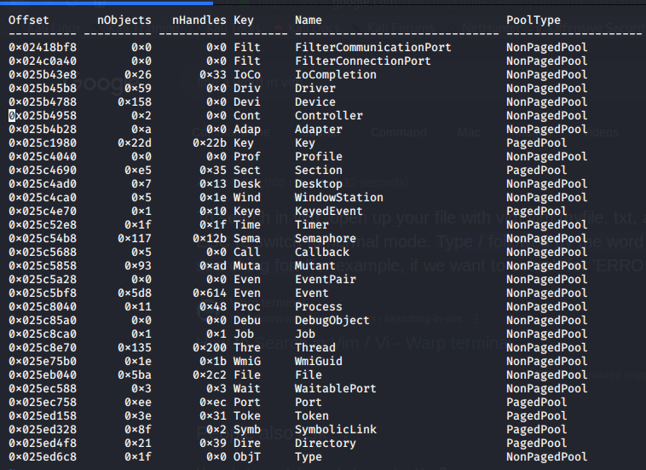

Object, Pools and Processes Image 2 -original pooltypescan output

The output generated from the plugin in figure Object, pools and processes Table 6 Contains 6 fields Object, pools and processes Table 3 offers a breakdown of the different fields and their relevance to the investigation.

|  |  |
| --- | --- |
| Field | Explanation |
| Offset | Offset is where the object can be found in the memory dump |
| nObjects | nObjects is the number of objects |
| nHandles | nHandles is the number of handles associated with the object |
| Key | Key is the 4 digit key used to identify the object |
| Name | Name is the name used to identify the Object |
| PoolType | PoolType specifies whether it is paged (written to disk/storage) or non-paged (in RAM/Not written to disk) |

Object, pools and processes Table 3 - Pooltypescan output explained.

To sort the different types, you must check between the two different types, Paged and NonPaged. One way to do this is by using the command in Object, pools and processes Table 4.

|  |  |
| --- | --- |
| Command | Output |
| grep NonPagedPool objtypescan.txt | grep is “a useful tool for string and pattern matching, allowing you to search through text files” (D.Mckay, 2023). In this case it is used to search for the string ‘NonPagedPool’ |

Object, pools and processes Table 4 - Filtering for the NonPagedPool items

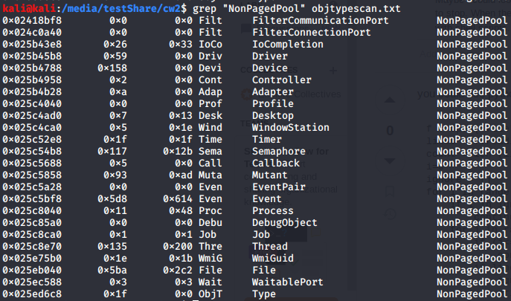

Object, Pools and Processes Image 3 - Filter for non paged pool items output

As can be seen from the output in Object, pools, and processes Image 3 there is the different types of non-paged pool objects.

There does not appear to be any reptations in there. One way to confirm this is by using the command in Object, pools and processes Table 5 & as can be seen in figure Object, pools, and processes Image 4 from the output there is the same number with or without sorting for uniqueness.

|  |  |
| --- | --- |
| Command | Output |
| grep NonPagedPool objtypescan.txt | wc -l | Here grep is used in conjunction with wc -l, the output of grep is given to wc -l using what is called a pipe denoted by the ‘|’ symbol |
| grep NonPagedPool objtypescan.txt | wc -l | sort -u | Here grep is used in conjunction with wc -l, the output of grep is given to wc -l using what is called a pipe denoted by the ‘|’ symbol |

Object, pools and processes Table 5 - Wordcount for normal and unique entries for NonPagedPool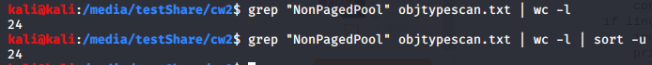

Object, Pools and Processes Image 4 - Associated outputs for the aforementioned greps

To get the Paged Pool items you must use the command in figure Object, pools and processes Table 6.

|  |  |
| --- | --- |
| Command | Output |
| grep -v “NonPagedPool” objtypescan.txt | grep with -v excludes the item being filtered for making it include any result that doesn’t contain NonPagedPool |

Object, pools and processes Table 6 - grep for PagedPool items

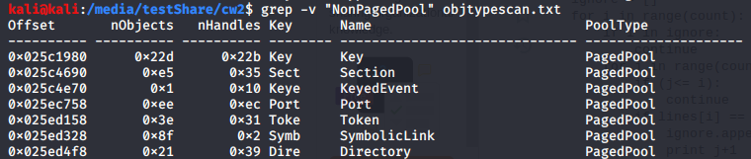

Object, Pools and Processes Image 5 - Output of grep with -v option

To sort these into unique and not unique you must run the two commands seen in Object, pools and processes Table 7 to get the difference between the unique entries and non-unique entries.

|  |  |
| --- | --- |
| Command | Output |
| grep -v “NonPagedPool” objtypescan.txt | sort -u | wc -l | grep with -v excludes the item being filtered for making it include any result that doesn’t contain NonPagedPool, the output is given to sort -u which is utilised to sort for unique entries and wc -l which then counts the lines left over |
| grep -v “NonPagedPool” objtypescan.txt | wc -l | grep with -v excludes the item being filtered for making it include any result that doesn’t contain NonPagedPool and wc -l which then counts the lines left over |

Object, pools and processes Table 7 - grep for the Paged Pool objects

Object, Pools and Processes Image 6 - resultant of the two commands

To filter based on the different keys in column 4 first the different keys must be retrieved from the file. To achieve this the command in Object, pools and processes Table 8 must be used.

|  |  |
| --- | --- |
| Command | Output |
| awk 'NR>2{print $4}' objtypescan.txt | sort -u | awk “used to filter and manipulate output from other programs” (D. Mckay, 2023). In this case it uses NR which is an abbreviation for number of rows, but it is used as a conditional to say if the number of rows (or row number) is above 2 as the first two lines are descriptive in nature and not useful output then print the fourth argument after this the output is piped to the sort command with -u to sort for unique entries |

Object, pools and processes Table 8 - awk command used with sort to filter for unique entries in the objtypescan output file

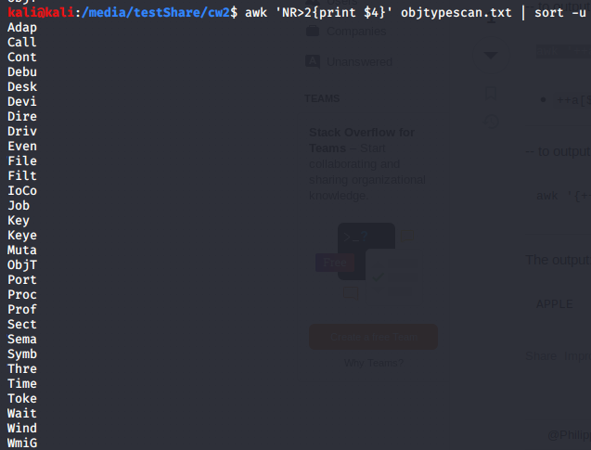

Object, Pools and Processes Image 7 - List of the Unique entries as resultant of the previous command

After getting all the key names use the command in figure Object, pools and processes Table 9 to count how many repetitions of that name there is.

|  |  |
| --- | --- |
| Command | Output |
| awk 'NR>2 && / Adap / {print}' objtypescan.txt | wc -l && awk 'NR>2 && / Call / {print}' objtypescan.txt | wc -l && awk 'NR>2 && / Cont / {print}' objtypescan.txt | wc -l && awk 'NR>2 && / Debu / {print}' objtypescan.txt | wc -l && awk 'NR>2 && / Desk / {print}' objtypescan.txt | wc -l && awk 'NR>2 && / Devi / {print}' objtypescan.txt | wc -l && awk 'NR>2 && / Dire / {print}' objtypescan.txt | wc -l && awk 'NR>2 && / Driv / {print}' objtypescan.txt | wc -l && awk 'NR>2 && / Even / {print}' objtypescan.txt | wc -l && awk 'NR>2 && / File / {print}' objtypescan.txt | wc -l && awk 'NR>2 && / Filt / {print}' objtypescan.txt | wc -l && awk 'NR>2 && / IoCo / {print}' objtypescan.txt | wc -l && awk 'NR>2 && / Job / {print}' objtypescan.txt | wc -l && awk 'NR>2 && / Key / {print}' objtypescan.txt | wc -l && awk 'NR>2 && / Keye / {print}' objtypescan.txt | wc -l && awk 'NR>2 && / Muta / {print}' objtypescan.txt | wc -l && awk 'NR>2 && / ObjT / {print}' objtypescan.txt | wc -l && awk 'NR>2 && / Port / {print}' objtypescan.txt | wc -l && awk 'NR>2 && / Proc / {print}' objtypescan.txt | wc -l && awk 'NR>2 && / Prof / {print}' objtypescan.txt | wc -l && awk 'NR>2 && / Sect / {print}' objtypescan.txt | wc -l && awk 'NR>2 && / Sema / {print}' objtypescan.txt | wc -l && awk 'NR>2 && / Symb / {print}' objtypescan.txt | wc -l && awk 'NR>2 && / Thre / {print}' objtypescan.txt | wc -l && awk 'NR>2 && / Time / {print}' objtypescan.txt | wc -l && awk 'NR>2 && / Toke / {print}' objtypescan.txt | wc -l && awk 'NR>2 && / Wait / {print}' objtypescan.txt | wc -l && awk 'NR>2 && / Wind / {print}' objtypescan.txt | wc -l && awk 'NR>2 && / WmiG / {print}' objtypescan.txt | wc -l | Awk is again used with NR (number of rows) attain the fields after the volatility descriptive rows then there is a && to denote straight after that this should be done and / [string] / is another variable used to filter the output for where the string contained within the back slashes will be searched for. After this output is piped to wc -l to get the wordcount displayed. To chain the commands together there is && used after wc -l to execute the command straight after that in turn searches for the next string until the list is exhausted. |

Object, pools and processes Table 9 - Awk chain to get all the number of different object types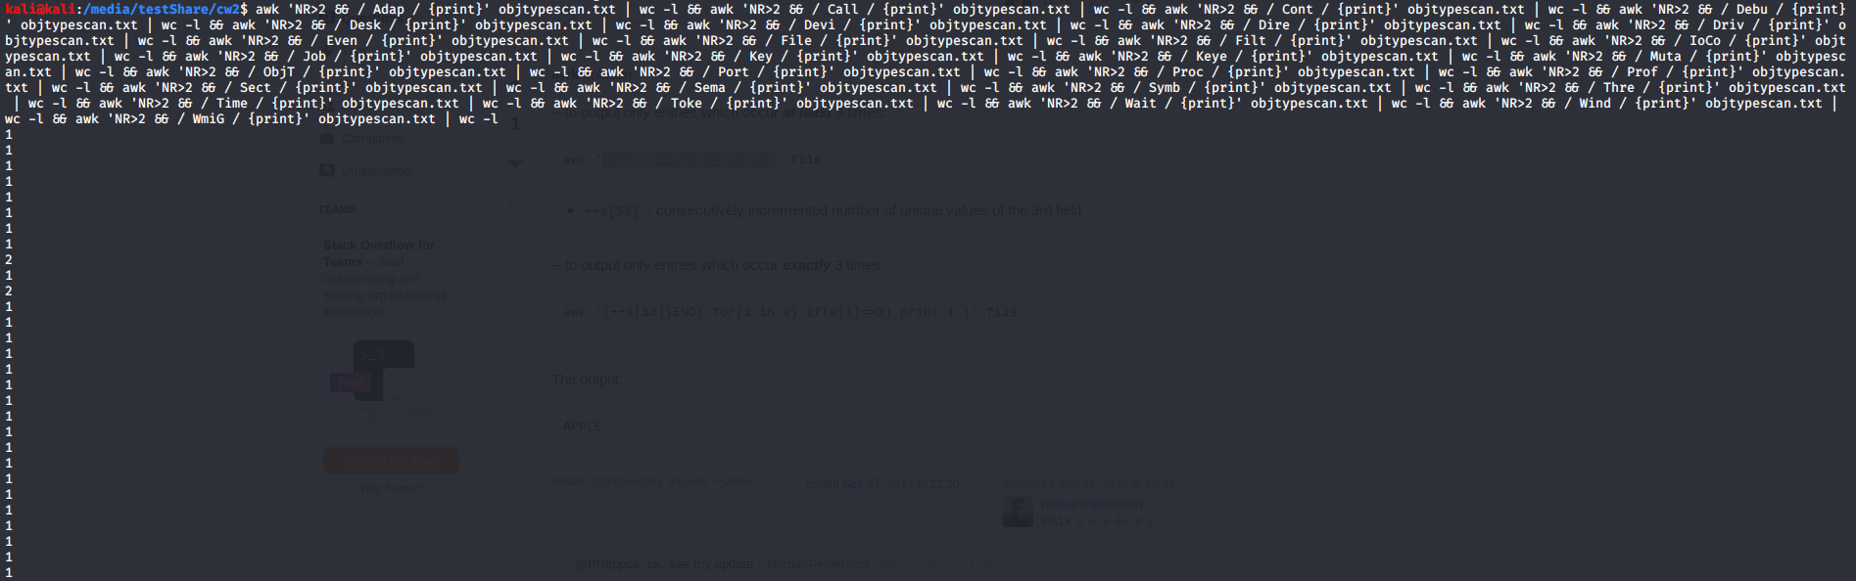

Object, Pools and Processes Image 8 - Aforementioned Command and its output

Mapped together the key names and the number of times they appear are shown in a small diagram below.

* Adap 1
* Call 1
* Cont 1
* Debu 1
* Desk 1
* Devi 1
* Dire 1
* Driv 1
* Even 2
* File 1
* Filt 2
* IoCo 1
* Job 1
* Key 1
* Keye 1
* Muta 1
* ObjT 1
* Port 1
* Proc 1
* Prof 1
* Sect 1
* Sema 1
* Symb 1
* Thre 1
* Time 1
* Toke 1
* Wait 1
* Wind 1
* WmiG 1

From the output the most common keys in the memory dump is Even and Filt appearing at two and the rest are at 1, to have a look at what the objects consist of use the command in Object, pools and processes Table 10.

|  |  |
| --- | --- |
| Command | Output |
| Awk “NR==1,NR==2; / Even /||/ Filt/ {print} ” objtypescan.txt | Awk with initial number of rows (NR) set to 1 then to 2 to display the headings, after this dilter for evan and filt. |

Object, pools and processes Table 10 - awk command to get the keys for filter and event

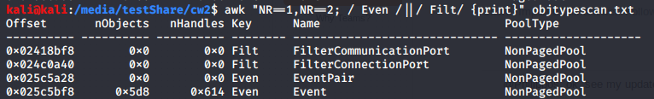

Object, Pools and Processes Image 9 - Image of the key and filter events output

All four appear to be NonPaged Pools therefore they have not been written to permanent storage yet but notably there is only one using handles. This encourages further analysis to distinguish whether it is the same for other objects. A command used to achieve this is in figure Object, pools and processes Table 11.

|  |  |
| --- | --- |
| Command | Output |
| awk '{ if ($2 != "0x0" && $3 != "0x0") print $0; }' objtypescan.txt | Awk is used as an if statement and it denotes IF the second argument ($2) and the third ($3) are both not equal to 0x0 (0 in hexadecimal) then the entire line should be printed ($0). The symbols may differ from the command displayed here due to linux changing what the != is represented as. |

Object, pools and processes Table 11 - Conditional awk statement to get any object with handles

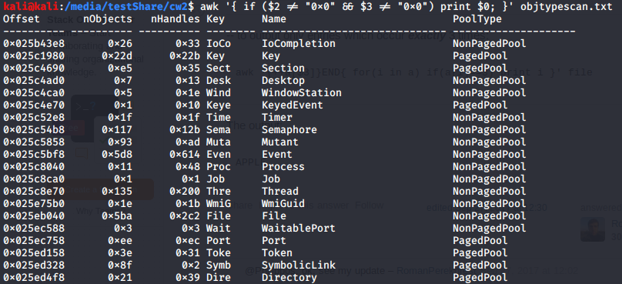

Object, Pools and Processes Image 10 - awk command conditional statements output

From this list in Object, Pools and Processes Image 10, the most in use in terms of both handles and is the Event indicating that there is a lot of activity happening on the computer especially for a windows XP machine. When converting the number displayed from hexadecimal there is

0x5d8 = 1496 Objects

0x614 = 1556 Objects

This could potentially be an indicator that the system has multiple users or additional events taking place without the knowledge of the person currently logged in.

### Clean Dump:

For the clean dump the same commands must be used to achieve a fair result to compare against the infected dump. To first extract the objects using the command in Object, pools and processes Table 12.

|  |  |
| --- | --- |
| Command | Output |
| volatility --plugins=/media/testShare/plugins -f /media/testShare/windowsclean.raw --profile=WinXPSP3x86 objtypescan – > cleanobjtypescan.txt | Use of the volatility objtypescan plugin to enumerate the objects |

Object, pools and processes Table 12 - Clean dump object type scan

After the file has been written to there is a need to filter between Paged and NonPaged Objects therefore use the commands in Object, pools and processes Table 13 to filter between the two.

Object, Pools and Processes Image 11 - Command output

|  |  |
| --- | --- |
| Command | Output |
| grep “NonPagedPool” cleanobjtypescan.txt | Grep is used to filter for NonPagedPool objects |
| grep -v “NonPagedPool” cleanobjtypescan.txt | Grep is used to filter for PagedPool objects as the -v will display anything that does not meet the string |

Object, pools and processes Table 13 - Clean dump greps to filter Paged and NonPagedPool objects

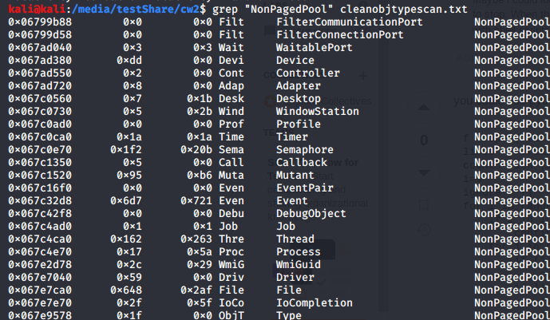

Object, Pools and Processes Image 12 - Non Paged Pool Objects

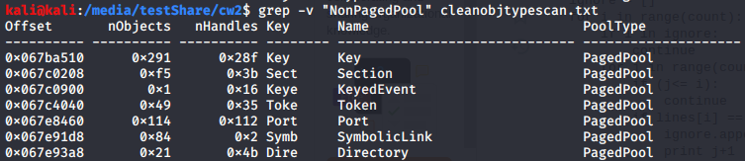

Object, Pools and Processes Image 13 - Paged Pool Objects

After this filter between the two to see if there are any repetitions by using the command in Object, pools and processes Table 14

|  |  |
| --- | --- |
| Command | Output |
| grep -v NonPagedPool | wc -l | Grep for not NonPagedPool |
| grep -v NonPagedPool | sort -u | wc -l | Grep for not NonPagedPool then sort & wordcount |

Object, pools and processes Table 14 - greps for PagedPool objcets



Object, Pools and Processes Image 14 – line count of PagedPool objects

To conduct a filter for NonPagedPool objects use the command in Object, pools and processes Table 15

|  |  |
| --- | --- |
| Command | Output |
| grep NonPagedPool | wc -l | Grep for NonPaged string |
| grep NonPagedPool | sort -u | wc -l | Grep for NonPaged string then sort and line count |

Object, pools and processes Table 15 - greps for NonPaged Pool objects

As can be seen in the above figures Object, pools and processes Image 14 & 15 after extensive analysis there are no repetitions in either dump hinting that no objects have been copied.

Object, Pools and Processes Image 15 - NonPagedPool line count

There is also the same amounts of Paged and non-paged objects in both dumps, 24 non paged objects and 7 paged objects (9-2 as there is two non-relevant lines being outputted from the filtering schemes.). To figure out how many different types of objects there are use the command in figure Object, pools and processes Table 16.

To filter based on the different keys in column 4 first the different keys must be retrieved from the file. To achieve this the command in Object, pools and processes Table 16 must be used.

|  |  |
| --- | --- |
| Command | Output |
| awk 'NR>2{print $4}' cleanobjtypescan.txt | sort -u | awk from line two onwards then sort for unique |

Object, pools and processes Table 16 - awk command to get the keys associated with the types from the clean dump

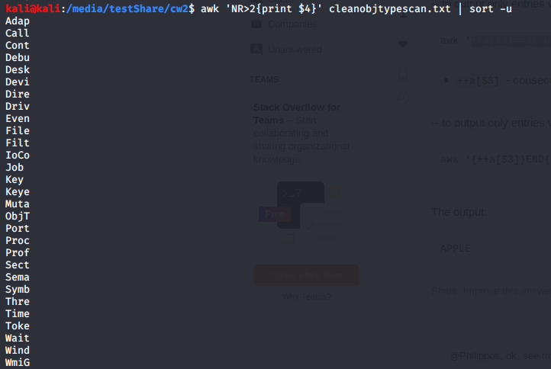

Object, Pools and Processes Image 16 - keys from the clean dump

After getting all the key names use the command in Object, pools and processes Table 17 to count how many repetitions of that name there is.

|  |  |
| --- | --- |
| Command | Output |
| awk 'NR>2 && / Adap / {print}' cleanobjtypescan.txt | wc -l && awk 'NR>2 && / Call / {print}' cleanobjtypescan.txt | wc -l && awk 'NR>2 && / Cont / {print}' cleanobjtypescan.txt | wc -l && awk 'NR>2 && / Debu / {print}' cleanobjtypescan.txt | wc -l && awk 'NR>2 && / Desk / {print}' cleanobjtypescan.txt | wc -l && awk 'NR>2 && / Devi / {print}' cleanobjtypescan.txt | wc -l && awk 'NR>2 && / Dire / {print}' cleanobjtypescan.txt | wc -l && awk 'NR>2 && / Driv / {print}' cleanobjtypescan.txt | wc -l && awk 'NR>2 && / Even / {print}' cleanobjtypescan.txt | wc -l && awk 'NR>2 && / File / {print}' cleanobjtypescan.txt | wc -l && awk 'NR>2 && / Filt / {print}' cleanobjtypescan.txt | wc -l && awk 'NR>2 && / IoCo / {print}' cleanobjtypescan.txt | wc -l && awk 'NR>2 && / Job / {print}' cleanobjtypescan.txt | wc -l && awk 'NR>2 && / Key / {print}' cleanobjtypescan.txt | wc -l && awk 'NR>2 && / Keye / {print}' cleanobjtypescan.txt | wc -l && awk 'NR>2 && / Muta / {print}' cleanobjtypescan.txt | wc -l && awk 'NR>2 && / ObjT / {print}' cleanobjtypescan.txt | wc -l && awk 'NR>2 && / Port / {print}' cleanobjtypescan.txt | wc -l && awk 'NR>2 && / Proc / {print}' cleanobjtypescan.txt | wc -l && awk 'NR>2 && / Prof / {print}' cleanobjtypescan.txt | wc -l && awk 'NR>2 && / Sect / {print}' cleanobjtypescan.txt | wc -l && awk 'NR>2 && / Sema / {print}' cleanobjtypescan.txt | wc -l && awk 'NR>2 && / Symb / {print}' cleanobjtypescan.txt | wc -l && awk 'NR>2 && / Thre / {print}' cleanobjtypescan.txt | wc -l && awk 'NR>2 && / Time / {print}' cleanobjtypescan.txt | wc -l && awk 'NR>2 && / Toke / {print}' cleanobjtypescan.txt | wc -l && awk 'NR>2 && / Wait / {print}' cleanobjtypescan.txt | wc -l && awk 'NR>2 && / Wind / {print}' cleanobjtypescan.txt | wc -l && awk 'NR>2 && / WmiG / {print}' cleanobjtypescan.txt | wc -l | NR is row number, the > sign prints other than first two, / [] / word is used to filter for the word then the && is used to chain the commands and display the output directly underneath allowing for linear analysis once using both methods. |

Object, pools and processes Table 17 - awk chain to count how many instances of the different keys there are

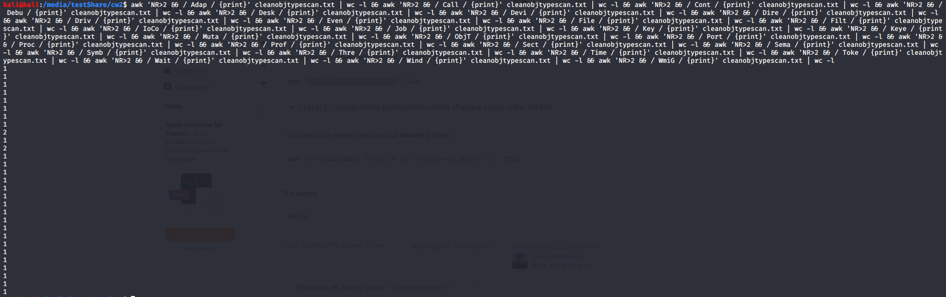

Object, Pools and Processes Image 17 – awk chain output

Mapped together the key names and the amount of times they appear are shown in a small diagram below

* Adap 1
* Call 1
* Cont 1
* Debu 1
* Desk 1
* Devi 1
* Dire 1
* Driv 1
* Even 2
* File 1
* Filt 2
* IoCo 1
* Job 1
* Key 1
* Keye 1
* Muta 1
* ObjT 1
* Port 1
* Proc 1
* Prof 1
* Sect 1
* Sema 1
* Symb 1
* Thre 1
* Time 1
* Toke 1
* Wait 1
* Wind 1
* WmiG 1

Just like in the infected dump, the output the most common keys in the memory dump is Even and Filt appearing at two and the rest are at 1, to have a look at what the objects consist of use the command in Object, pools and processes Table 18.

|  |  |
| --- | --- |
| Command | Output |
| awk "NR==1,NR==2; / Even /||/ Filt/ {print}" cleanobjtypescan.txt | Awk with both header lines then print lines with Even & Filt strings |

Object, pools and processes Table 18 - command to filter for events and filters

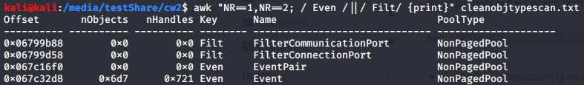

Object, Pools and Processes Image 18 - Event and filter command output

All four appear to be NonPaged Pools therefore they have not been written to permanent storage yet but notably there is only one using handles. This encourages further analysis to distinguish whether it is the same for other objects. A command used to achieve this is in Object, pools and processes Table 19.

|  |  |
| --- | --- |
| Command | Output |
| awk '{ if ($2 != "0x0" && $3 != "0x0") print $0; }' cleanobjtypescan.txt | If statement checking both columns not equal to 0x0 then printing the resultant |

Object, pools and processes Table 19 - filtering for processes with objects and handles

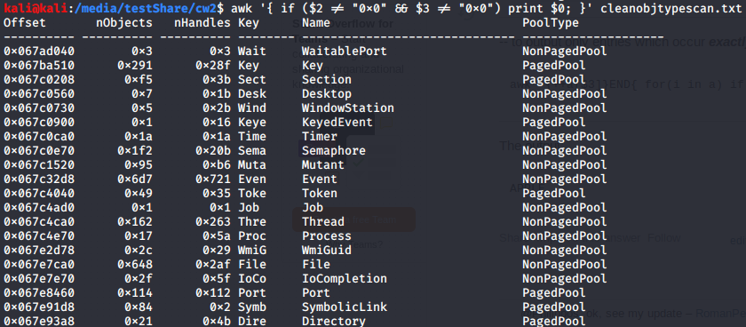

Object, Pools and Processes Image 19 - Processes with handles and objects

From this list the most in use in terms of both handles and is the Event indicating that there is a lot of activity happening on the computer especially for a windows XP machine. When converting the number displayed from hexadecimal there is

0x6d7 = 1751 Objects

0x721 = 1825 Objects

There is many more objects and handles in the clean dump compared to the infected dump. This could be an indication that there has been some hidden or altered handles in the infected dump. It could however just be that there is less activity taking place on the infected dump as opposed to the clean dump.

## 2. List the different Windows Station objects in both memory dumps and scan them. How many of them can you find? What are their names? (10%) //

### Infected Dump:

A station is a session utilising the computer system in memory that is “tied to a particular user” (Ligh et al, 2014) & also creating a table that allows for the “resources linked to the session” (Ligh et al, 2014) to be “attributed back to actions performed by the user” (Ligh et al, 2014).

To find the different stations, the plugin used is the wndscan, and the command used to display the output is as seen in Object, pools and processes Table 20.

|  |  |
| --- | --- |
| Command | Output |
| volatility --plugins=/media/testShare/plugins -f /media/testShare/cw2_Machine4Infected.dump --profile=WinXPSP2x86 wndscan --output-file=/media/testShare/cw2/wndscan2.txt | The output generated is of every instance of a station. This output is given to the file wndscan.txt for later use |
| cat wndscan.txt | Cat displays the entirety of the file, in this case it is the newly created wndscan.txt |
| grep WindowStation wndscan.txt | Grep for WindowStation string in the wndscan.txt file |

Object, pools and processes Table 20 - Creation and filtering of output from the wndscan plugin

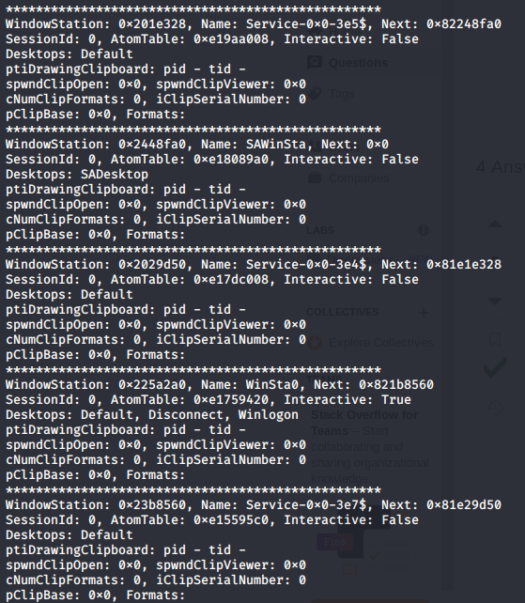

Object, Pools and Processes Image 20 - wndscna output

The output contains a myriad of fields, as explained in figure Object, pools and processes Table 21

|  |  |
| --- | --- |
| Field | Explanation |
| Window Station | Window station denotes the offset where the window station can be found |
| Name | Name is the name of the window station object |
| Next | Next is the “used to enumerate all window stations in the same session as the current one” (High, 2012) |
| Session ID | Session ID is the session that the windows station is assigned to |
| Atom Table | Atom table is the offset for the atom table where the allocated |
| Interactive | Interactive denotes whether the station is interactive or not |
| ptiDrawingClipboard | Drawingclipboard is the PID carrying the clipboard |
| spwndClipOpen | spwndClipOpen Displays how many times the clipboard is opened |
| spndClipViewer | spndClipViewer Displays the number of times the clipboard has been Accessed |
| cNumClipFormats | How many formats of the clipboard there is (utf-e, ascii etc) |
| iClipSerialNumber | iclipSerialNumber is the Serial number of the clipboard. |
| pClipBase | iclipBase is the base offset for the clipboard |

Object, pools and processes Table 21 - wndscan plugin explained

Some instant observations from looking at figure Object, pools and processes Image 20 is that there are no clipboards whatsoever in the infected dump, also the only interactive station in the session is WinSta0 which is a representation of the first windows station assigned to the only visible session in the windows environment. If there were more there would be WinSta1, WinSta2 etc.

To filter out how many As seen from figure Object, pools and processes Image 22 there are 5 instances of windows stations contained in one session. To get the name of the different window stations simply use the command seen in Object, pools and processes Table 22

|  |  |
| --- | --- |
| Command | Output |
| grep Name wndscan.txt | Grep for Name from the windscan.txt file |
| grep WindowStation wndscan.txt | wc -l | Grep for WindowStation and then linecount output |

Object, pools and processes Table 22 - Name grep and linecount for the names

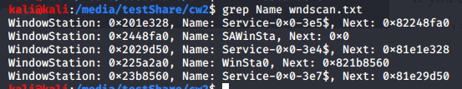

Object, Pools and Processes Image 21 - name grep

Object, Pools and Processes Image 22 - line count for the names

From the output in Object, pools and processes Image 21 above it can be seen the names of the 5 stations are:

* Service-0x0-3e5$
* SAWinsta
* Service-0x0-3e7$
* WinSta0
* Service-0x0-3e7$

### Clean Dump:

To find the different stations in the clean dump, the plugin used is the wndscan, and the command used to display the output is as seen in Object, pools and processes Table 23 & Table 24.

|  |  |
| --- | --- |
| Commmand | Output |
| volatility --plugins=/media/testShare/plugins -f /media/testShare/windowsclean.dump --profile=WinXPSP2x86 wndscan --output-file=/media/testShare/cw2/cleanwndscan.txt | The output generated is of every instance of a station., this is then outputted to the cleanwndscan.txt file |

Object, pools and processes Table 23 - wndscan command for the clean dump

|  |  |
| --- | --- |
| Comand | Output |
| Grep WindowStation cleanwndscan.txt | wc -l | Grep for WindowStation then linecount output |

Object, pools and processes Table 24 - grep for window station



Object, Pools and Processes Image 23 - previous grep output

Just like the infected dump, the clean dump also utilises 5 different stations objects that are of the same station indicating there has been no compromise in terms of the number of windows that are currently open on the computer systems.

Their names can be uncovered by running grep on the outputted text file as seen in Object, pools and processes Table 25.

|  |  |
| --- | --- |
| Command | Output |
| grep Name cleanwndscan.txt | Grep for Name |

Object, pools and processes Table 25 - grep for name

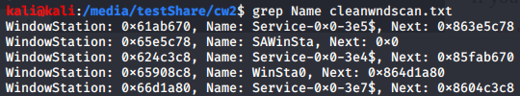

Object, Pools and Processes Image 24 - grep for the name

The names for the 5 stations objects are:

* Service-0x0-3e5$
* SAWinsta
* Service-0x0-3e7$
* WinSta0
* Service-0x0-3e7$

## 3. Identify every process that has an associated user, name the user, and discuss the level of privileges of each user in both memory dumps. (10%) //

### Infected Dump:

To answer this question the first thing that must be done is the acquisition of both the processes and the privilege levels of the users inside the memory dump. The first command run is as seen in figure Object, pools and processes Table 26 below & the output can be seen just below in Object, pools and processes Image 25.

|  |  |
| --- | --- |
| Command | Output |
| volatility -f /media/testShare/cw2_Machine4Infected.dump --profile=WinXPSP2x86 pslist | Volatility command to get pslist, which is a list of the processes |

Object, pools and processes Table 26 - pslist command

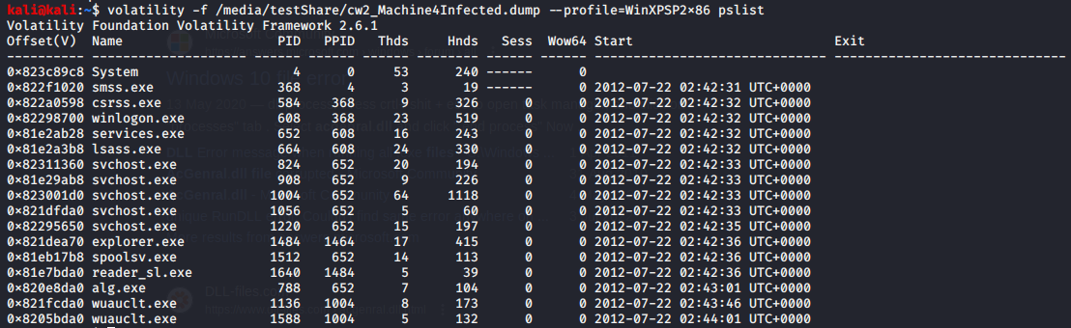

Object, Pools and Processes Image 25 - pslist command output

The output columns from figure Object, pools and processes Image 31 explained in the table in figure Object, pools and processes Table 27 below.

|  |  |
| --- | --- |
| Column | Explanation |
| Offset | The offset that the process was found |
| Name | Name of the executeable |
| PID | Process Identifier |
| PPID | Parent Process Identifier |
| Thds | Threads associated with the process |
| Hnds | Handles associated with the process |
| Sess | The session that the process is in |
| Wow64 | Denotes “if the process is a Wow64 process (it uses a 32 bit address space on a 64 bit kernel)” (Gleeda, 2020). 0 is false and 1 is true. |

Object, pools and processes Table 27 - pslist command output explained

One way to identify users and their privileges is by using envars then grep the output, save to a txt file for convenience. The plugin envars is used as it displays key information that can be used to identify the user that executed the command such as the “session name, computer name, user name” (gleeda, 2020). The command used is seen in Object, pools and processes Table 28.

|  |  |
| --- | --- |
| Command | Output |
| volatility --plugins=/media/testShare/plugins -f /media/testShare/cw2_Machine4Infected.dump --profile=WinXPSP3x86 envars > envars.txt | Command to get envars, which is environmental variables |

Object, pools and processes Table 28 - envars command

Object, Pools and Processes Image 26 - envars command output

The next thing to do is to discover who the users are, and this can be done using the command in figure Object, pools and processes Table 29 This command lists the users that can be found in the “user-specific Registry hive named USRCLASS.dat” (C. Tilbury, 2011) that can be used to enumerate the users as there is a “USRCLASS.dat for each user account” (C. Tilbury, 2011). With every instance is a user account associated with it as identified in Object, Pools and Processes Image 27 below.

|  |  |
| --- | --- |
| Command | Output |
| volatility --plugins=/media/testShare/plugins -f /media/testShare/cw2_Machine4Infected.dump hivelist | grep UsrClass | Hivelist, which lists the registries associated to the memory dump and grepping for UsrClass. |

Object, pools and processes Table 29 - grep for UsrClasss on the hivelist plugin

As can be seen in figure Object, pools and processes Image 27, there are three accounts found. Robert, LocalService and NetworkService.

Object, Pools and Processes Image 27 - result of the grep

After this catting the entirety of envars using the command in Object, pools and processes Table 30 displays 4 fields as seen in Object, pools and processes Image 28.

|  |  |
| --- | --- |
| Command | Explanation |
| cat envars.txt | Cat to display the full |

Object, pools and processes Table 30 - cat command

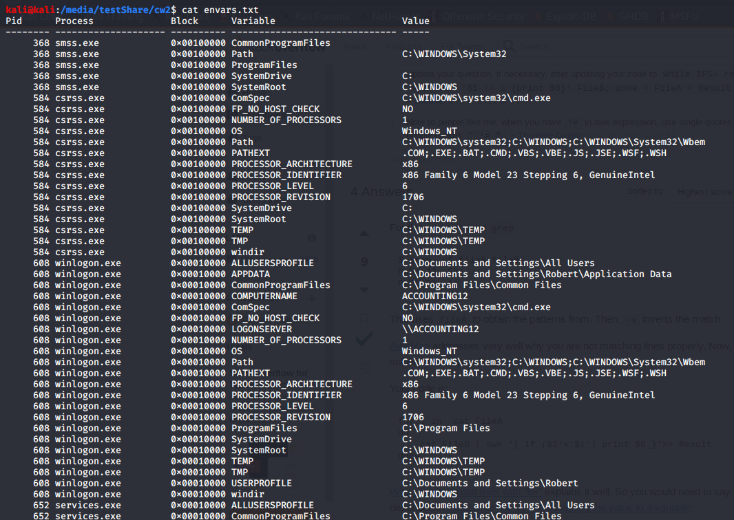The four fields that envars.txt contains are as explained in Object, pools and processes Table 31:

Object, Pools and Processes Image 28 - cat envars output

|  |  |
| --- | --- |
| Field | Explanation |
| PID | Process Identifier |
| Process | Process |
| Block | The block the variables were found in |
| Variable | The type of variable that has been identified |
| Value | The value contained in that variable |

Object, pools and processes Table 31 - envars explanation

As catting the entire file gives too much output grep will be used to filter the different outputs. There will be a filter applied for every process relevant to the question.

Critical system processes (Idle, System, csrss, services.exe, lsass.exe, winlogon.exe, explorer.exe, smss.exe) will be skipped, the next process from pslist will be identified. Below in Object, pools and processes Table 32 is the output for the process 824.

|  |  |
| --- | --- |
| Command | Output |
| grep 824 cw2/envars.txt | grep is a command line tools used to filter for “lines containing a match to a specified pattern” (GNU, No Date). The pattern that is being matched is the number 824, to get the environmental variables associated to PID 824, and the last argument of the command executed is the file that the pattern matching will be performed on. |

Object, pools and processes Table 32 - grep for PID 824

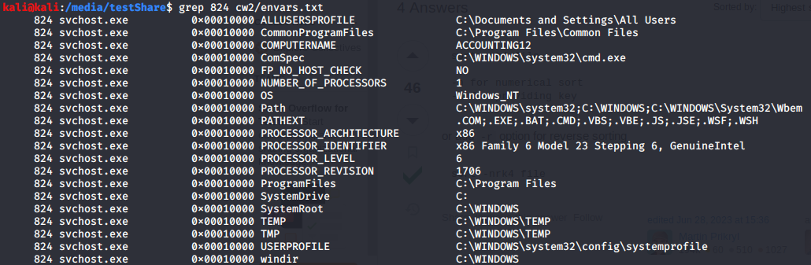Process 824, svchost.exe, is another process that is not associated with a specific user and is used as a “generic host process for services” (C.Marcho, 2019). So, it makes sense for there to be a myriad of svchosts in the pslists output as seen in Object, pools and processes Image 28. This svchost.exe has been triggered from the configuration directory of the system profile so it is likely startup configurations.

Object, Pools and Processes Image 29 - PID 824 associated enviromental variables

From the previous processes such as winlogon that can be seen Object, pools and processes Image 29 it can be assumed the computer has just started up & upon startup svchost.exe “checks the registry to determine which services it should load” (C.Marcho, 2019). The key being checked is “HKEY_LOCAL_MACHINE\SOFTWARE\Microsoft\Windows NT\CurrentVersion\Svchost” (C.Marcho, 2019).

|  |  |
| --- | --- |
| Command | Output |
| grep 908 cw2/envars.txt | grep for the number 908, to get the environmental variables associated to PID 908 |

Object, pools and processes Table 33 - grep for PID 908 envars

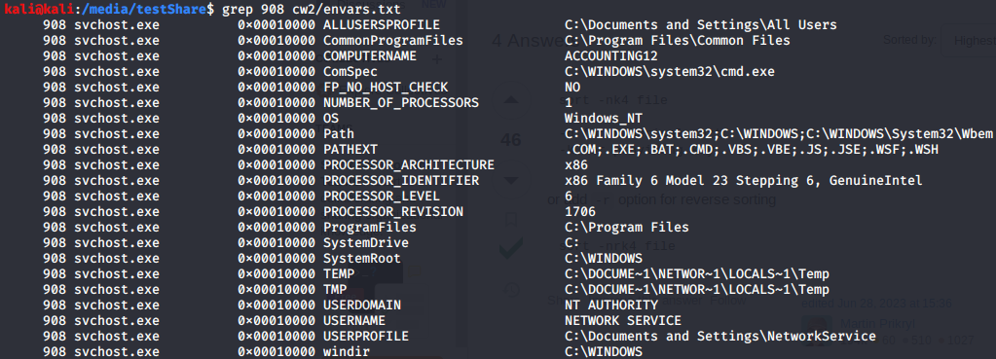

Object, Pools and Processes Image 30 - PID 908 envars

Process 908, svchost.exe, is another instance of svchost that is not associated with a specific user and is used as a “generic host process for services” (C.Marcho, 2019). This svchost.exe has been triggered from the NetworkService directory therefore is used for a networking service that has been triggered by NT AUTHORITY which is a “predefined local account” (Microsoft, 2021) that has “access to most system objects” (Microsoft, 2021).

|  |  |
| --- | --- |
| Command | Output |
| grep 1004 cw2/envars.txt | grep for the number 1004, to get the environmental variables associated to PID 1004. |

Object, pools and processes Table 34 - grep for PID 1004 envars

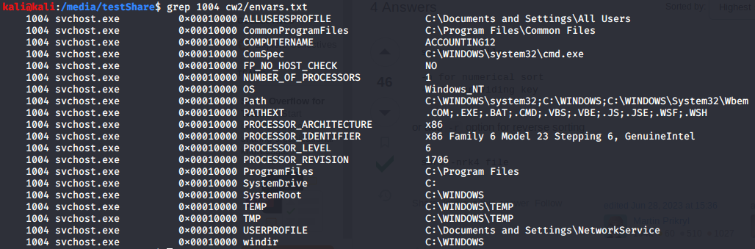

Object, Pools and Processes Image 31 - PID 1004 envars

Process 1004, svchost.exe, is another instance of svchost that is not associated with a specific user and is used as a “generic host process for services” (C.Marcho, 2019). This svchost.exe has been triggered from the NetworkService directory therefore is used for networking. Notably this process hasn’t been triggered by NT AUTHORITY. The case is the same for the clean dump so this may not be a strange occurrence.

|  |  |
| --- | --- |
| Command | Output |
| grep 1056 cw2/envars.txt | grep for the number 1056, to get the environmental variables associated to PID 1056 |

Object, pools and processes Table 35 - grep for PID 1056 envars

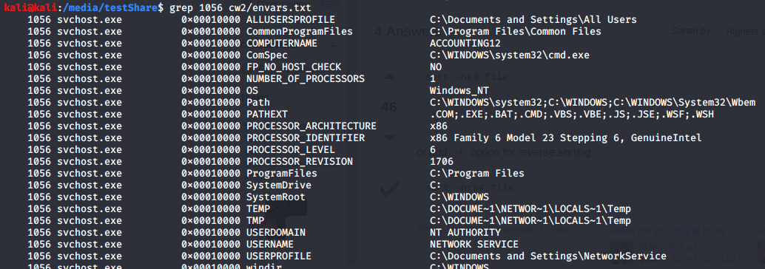

Object, Pools and Processes Image 32 - PID 1056 envars

Process 1056, svchost.exe, is another instance of svchost that is not associated with a specific user and is used as a “generic host process for services” (C.Marcho, 2019). This svchost.exe has been triggered from the NetworkService directory therefore is used for networking & has been triggered by NT AUTHORITY which is a “predefined local account” (Microsoft, 2021) that has “access to most system objects” (Microsoft, 2021).

|  |  |
| --- | --- |
| Command | Output |
| grep 1220 cw2/envars.txt | grep for the number 1220, to get the environmental variables associated to PID 1220 |

Object, pools and processes Table 36 - grep for PID 1220 envars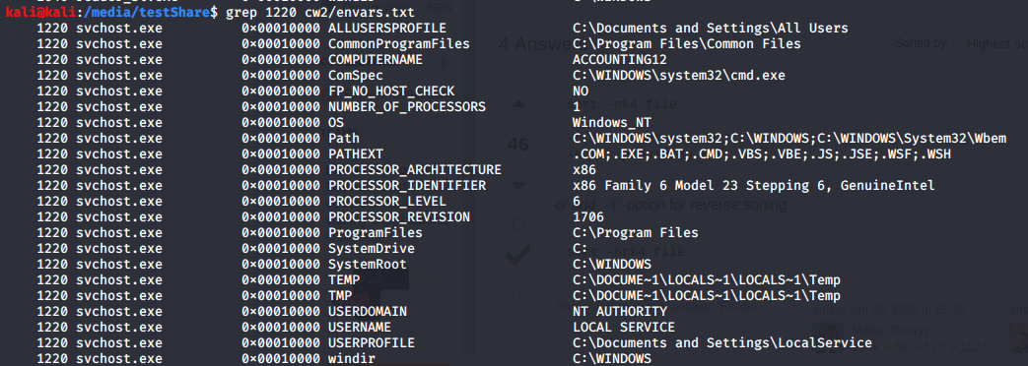

Object, Pools and Processes Image 33 - PID 1220 envars

Process 1004, svchost.exe, is another instance of svchost that is not associated with a specific user and is used as a “generic host process for services” (C.Marcho, 2019). This svchost.exe has been triggered from the LocalService directory which is a “predefined local account used by the service control manager” that has been triggered by NT AUTHORITY which is a “predefined local account” (Microsoft, 2021) that has “access to most system objects” (Microsoft, 2021).

|  |  |
| --- | --- |
| Command | Output |
| grep 1512 cw2/envars.txt | grep for the number 1512, to get the environmental variables associated to PID 1512 |

Object, pools and processes Table 37 - grep for PID 1512 envars

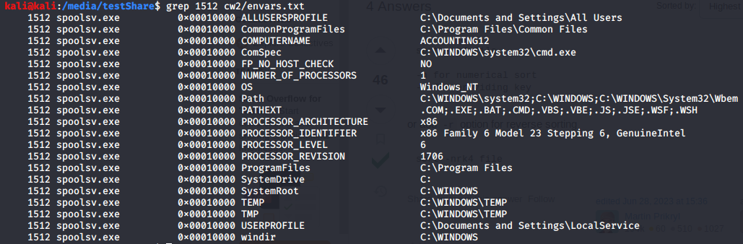Process 1512, spoolsv.exe, is a process that “handles printing” (C.Hoffman, 2017) for windows. It has been started up by the LocalService which is a “predefined local account used by the service control manager” (Microsoft, 2021).

Object, Pools and Processes Image 34 - PID 1512 envars

|  |  |
| --- | --- |
| Command | Output |
| grep 1640 cw2/envars.txt | grep for the number 1640, to get the environmental variables associated to PID 1640 |

Object, pools and processes Table 38 - grep for 1640 envars

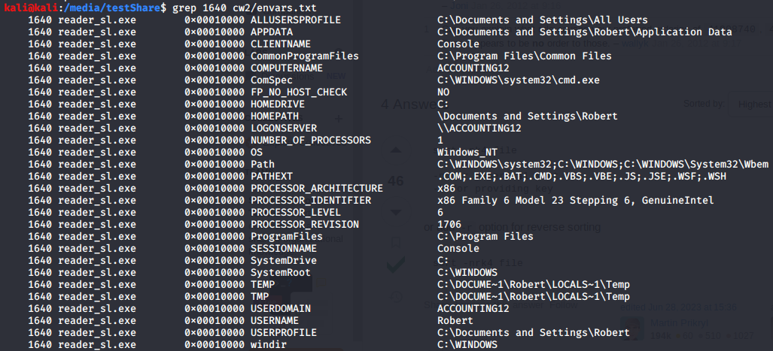

Object, Pools and Processes Image 35 - PID 1640 envars

Process 1640, reader_sl.exe, has been spawned by Robert as can be seen in Object, pools and Processes Image 35 where the username is Robert. Reader_sl.exe is an “executable file that belongs to Adobe Acrobat, a group of software and web services created by Adobe, to create, view, modify and print files in the Portable Document Format” (file.net, 2024). This could indicate that there was a PDF (Portable Document Format) that was opened, the PDF may be the entry point into the system that caused the infection. Reader_sl is also not seen being triggered in the clean dump.

Some further analysis can be run on this as it is an anomaly. The first thing to do is to find out if there are any more instances of the pdf in the memory sample using strings and a simple grep as seen in Object, pools and Processes Image 36 by utilising the command in Object, pools and Processes Table 39.

|  |  |
| --- | --- |
| Command | Output |
| strings cw2_Machine4Infected.dump | egrep "pdf|PDF" | Strings to display any strings and a grep for PDF or pdf |

Object, pools and processes Table 39 - string ang egrep command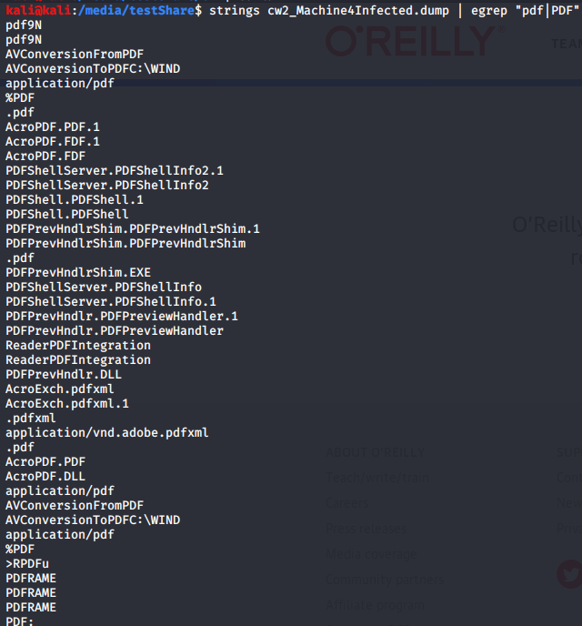

Object, Pools and Processes Image 36 - command output

From the output displayed and highlighted in red it can be seen that in Object, Pools and Processes Image 36 there has been conversion from a PDF to a DLL file (AcroPDF), utilising AVConversion functionality from Adobe that facilitates the “conversion of documents from PDF to other formats” (Adobe, 2022), and there is also a PDFShellServer that potentially points towards a PDF being used or a file that was a PDF being used in order to facilitate the exploitation of this machine.

To do this, run the command in Object, pools and processes Table 40 to start conducting scans against this anomaly to investigate further.

|  |  |
| --- | --- |
| Command | Output |
| vim pdf.yar | Creates a yara file |
| rule address_resolution{  strings:  $a = "PDF" wide ascii  $b = "pdf" wide ascii  $c = "AVConv" wide ascii  $d = "AcroPDF.DLL" wide ascii  $e = "reader_sl" wide ascii  $f = "shell" wide ascii  condition:  any of them  } | Rule declares the name of the rule  Strings declares the strings to search for in the form of variables  Condition declares what a positive should look like |

Object, pools and processes Table 40 - creation of pdf.yar rule file & the rule files code explained

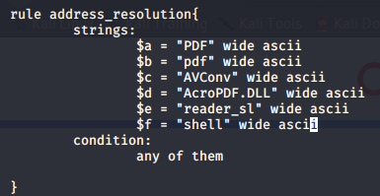

Object, Pools and Processes Image 37 - yarascan file code

Then run the command in Object, pools and processes Table 41 in order to get the result of the yarscan

|  |  |
| --- | --- |
| Command | Output |
| volatility --plugins=/media/testShare/plugins -f /media/testShare/cw2_Machine4Infected.dump yarascan -y pdf.yar > pdfparsing.txt | The use of the yarascan based on the yarafile that was created |

Object, pools and processes Table 41 - yarascan command

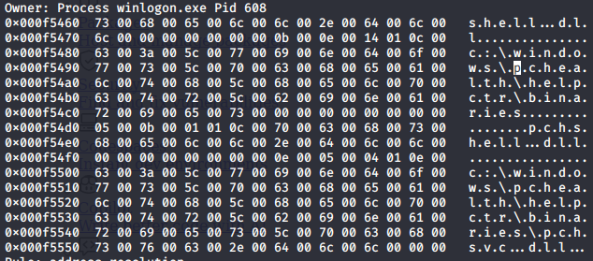The output is omitted but contains some interesting data such as in Object, pools and processes Image 38. There is a folder named pchealth but there is no PC health in windows XP, more alarming is that it has been executed with winlogon so this would hint at some level of persistence in the system.

Object, Pools and Processes Image 38 - pchealth finding

Continuing with the PID envars chain is the command Object, pools and processes Table 42.

|  |  |
| --- | --- |
| Command | Output |
| grep 788 cw2/envars.txt | grep for the number 788, to get the environmental variables associated to PID 788 |

Object, pools and processes Table 42 - grep for PID 788

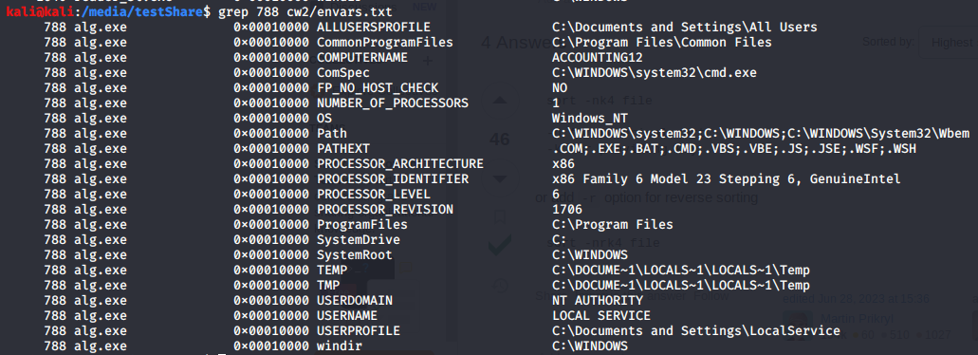

Object, Pools and Processes Image 39 - PID 788 envars

In process 788, alg.exe, “is responsible for providing support for Internet Connection Sharing (ICS) and the Windows Firewall” (S.Picili, 2023). This is another executable that is instantiated by the OS & is triggered by Process 608, services.exe to retain regular computer functionality.

|  |  |
| --- | --- |
| Command | Output |
| grep 1136 cw2/envars.txt | grep for the number 1136, to get the environmental variables associated to PID 1136, and the last argument of the command executed is the file that the pattern matching will be performed on |

Object, pools and processes Table 43 - grep for PID 1136 envars

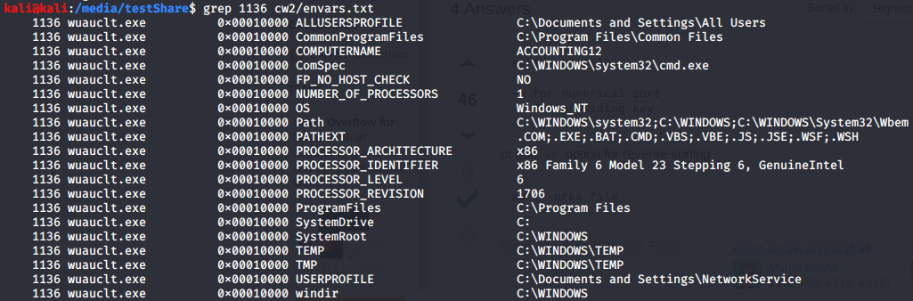

Object, Pools and Processes Image 40 - PID 1136 envars

Process 1136, wuauclt.exe, is spawned by process 1004, svchost.exe that is related to Network service though was not triggered by NT AUTHORITY despite other network service svchosts being triggered from NT AUTHORITY. Process 1136 appears to also be a network service which would make sense at wuauclt.exe is used to search for and perform updates to the computer system.

|  |  |
| --- | --- |
| Command | Output |
| grep 1588 cw2/envars.txt | grep for the number 1588, to get the environmental variables associated to PID 1588, and the last argument of the command executed is the file that the pattern matching will be performed on |

Object, pools and processes Table 44 - grep for PID 1588 envars

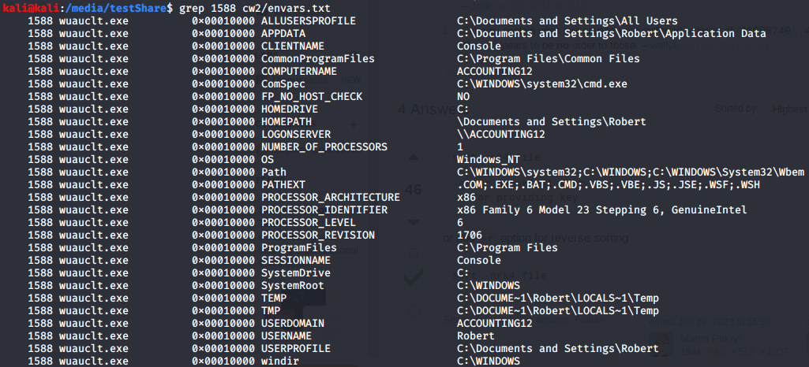

Object, Pools and Processes Image 41 - PID 1588 envars

Process 1588, Wuauclt.exe, appears to have been triggered by the User Robert and from Roberts Documents and setting directory.

After looking at all the processes the processes with a username or userprofile that can be used to identify them are as seen in figure Object, pools and processes Table 45.

|  |  |
| --- | --- |
| Username | Processes |
| Robert | explorer.exe: PID 1484  reader_sl.exe: PID 1640  Wuauclt.exe: PID 1588 |
| LocalService | svchost.exe: PID 1220 (with NT AUTHORITY)  spoolsv.exe: PID 1512  alg.exe: PID 788 (with NT AUTHORITY) |
| Systemprofile | svchost.exe: PID 824 |
| NT AUTHORITY | Svchost.exe: PID 1056 (with NetworkService)  svchost.exe: PID 1220 (with LocalService)  alg.exe: PID 788 (with LocalService) |
| Network Service | Scvhost.exe: PID 908  Svchost.exe: PID 1004  Svchost.exe: PID 1056 (with NT AUTHORITY)  Wuauclt.exe: PID 1136 |

Object, pools and processes Table 45 - Enumerated Users and their associated PID's

One way to confirm this output for Robert is to use getsids. The output is seen in figure Object, pools and processes Image 42 confirming the PID’s that were found using envars. The commands used are in Object, pools and processes Table 46.

|  |  |
| --- | --- |
| Command | Output |
| volatility -f /media/testShare/cw2_Machine4Infected.dump --profile=WinXPSP3x86 getsids > ../cw2/getsids.txt | Get the security identifiers for the dump then import them into the getsids file |
| Cat /media/testShare/cw2/getsids.txt | grep Robert | Grep for the name Robert in the getsids file |

Object, pools and processes Table 46 - getsids and output of getsids

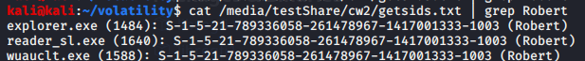

Object, Pools and Processes Image 42 - Roberts associated PID's

Another way to check what privileges the end user may have is to extract the SAM registry file and then once the file is extracted to allow for the file to be utilized by a tool named sampasswd. To execute this, use the command in Object, pools and processes Table 47 to make a folder and get the dump for the infected dump.

|  |  |
| --- | --- |
| Command | Output |
| Mkdir dumpedRegistry | Make a dumpedRegistry directory |
| volatility --plugins=/media/testShare/plugins -f /media/testShare/cw2_Machine4Infected.dump --profile=WinXPSP3x86 dumpregistry --dump-dir dumpedRegistry/ | Use the dumpregistry plugin to dump all the registry files to the newly made directory |

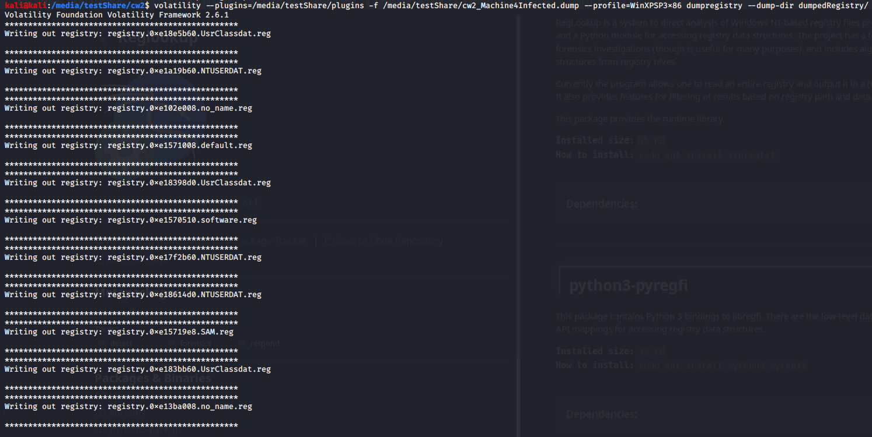Object, pools and processes Table 47 - Making a directory and dumping the registry into that directory

Object, Pools and Processes Image 43 - dumpregistry output

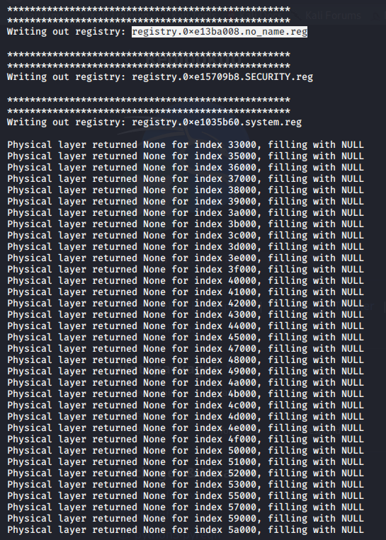

Object, Pools and Processes Image 44 - dumpregistry output continued

After this utilise sampasswd by using the command in figure Object, pools and processes Table 48.

|  |  |
| --- | --- |
| Command | Output |
| sampasswd -H -l registry.0xe1579e8.SAM.reg | Sampasswd is a linux tool that can be used to parse registry information. The switch -H gives “human readable output” (Linux Manuals, nd) and the -l that “Lists the users in the SAM” (Linux Manuals, nd). Here it is used on the infected dump and produces 5 different users |

Object, pools and processes Table 48 - sampasswd command

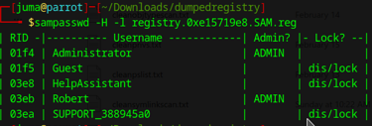

Object, Pools and Processes Image 45 - sampasswd command output

As can be seen just above in Object, pools and processes Image 45 there are two administrators, One is Robert, and the other is the default administrator that can be found in any windows XP. This confirms the privileges assigned to the user Robert.

### Clean Dump:

First pslist must be used to enumerate the different processes.

|  |  |
| --- | --- |
| Command | Output |
| volatility -f /media/testShare/windowsclean.raw --profile=WinXPSP3x86 pslist | Process listing for the clean dump |

Object, pools and processes Table 49 - pslist

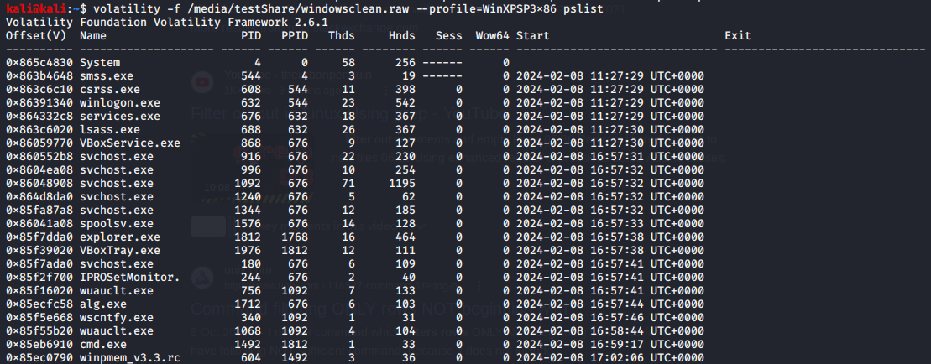

Object, Pools and Processes Image 46 - pslist output

Once pslist has been used a check can be conducted for how many users are in the machine using the command in Object, pools and processes Table 50.

|  |  |
| --- | --- |
| Command | Output |
| volatility --plugins=/media/testShare/plugins -f /media/testShare/windowsclean.raw hivelist | grep UsrClass | Running the hivelist plugin to get the res#gistry files then grepping for UsrClass |

Object, pools and processes Table 50 - hivelist command



Object, Pools and Processes Image 47 - different users identified

As seen in Object, pools and processes Image 47 the UsrClass.dat registry identifies 3 different users:

* Voidead
* LocalService
* NetworkService

After discovering this the next step is to find out what is associated with these users. To do this run the command in figure Object, pools and processes Table 51 then filter through the output.

|  |  |
| --- | --- |
| Command | Output |
| volatility -f /media/testShare/windowsclean.raw --profile=WinXPSP3x86 envars --output-file=/media/testShare/cw2/cleanenvars.txt | Running the envars file then outputting to a text file |

Object, pools and processes Table 51 - envars command



Object, Pools and Processes Image 48 - envars command output

After this the file must be filtered to establish the different commands different environmental variables there are. This can be achieved using the commands that follow. The first command used is in figure Object, pools and processes Table 52.

|  |  |
| --- | --- |
| Command | Output |
| grep 868 /media/testShare/cw2/cleanenvars.txt | Grep for PID 868 envars |

Object, pools and processes Table 52 - Grep for PID 868 envars

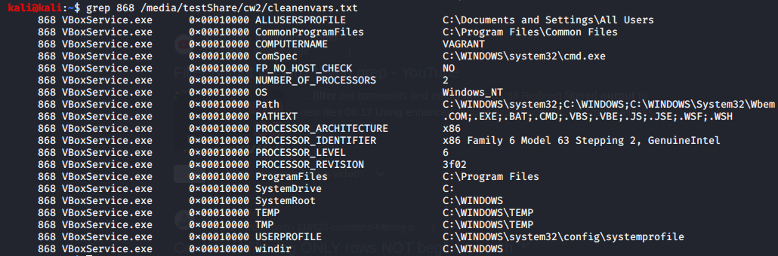

Object, Pools and Processes Image 49 - envars output

Process 868, VBoxService.exe, is where the processes become different to the infected dumps chronological order. VBoxService.exe “is a set of drivers and system applications that are designed to make the interaction between the host and guest operating systems more seamless” (file.net, 2024) utilised by the virtualisation machine that the windows XP is being run on, VirtualBox.

|  |  |
| --- | --- |
| Command | Output |
| grep 1576 /media/testshare/cw2/cleanenvars.txt | grep for the number 1576, to get the environmental variables associated to PID 1576, and the last argument of the command executed is the file that the pattern matching will be performed on |

Object, pools and processes Table 53 - grep for PID 1576 envars

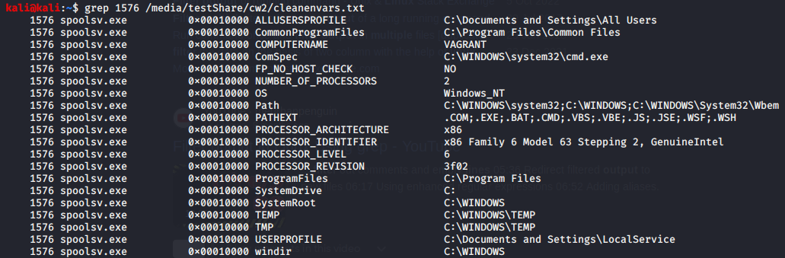

Object, Pools and Processes Image 50 - PID 1576 envars

Process 1576, spoolsv.exe, also exists in the infected dump, whilst it is not chronological (in regards to being parallel with the infected dump), it does bear similar variables excluding the CPU’s details and name. It also like in the infected dump has been triggered by services.exe as denoted by the PPID (676).

|  |  |
| --- | --- |
| Command | Output |
| grep 1812 /media/testshare/cw2/cleanenvars.txt | grep for the number 1812, to get the environmental variables associated to PID 1812 |

Object, pools and processes Table 54 - grep for PID 1812 envars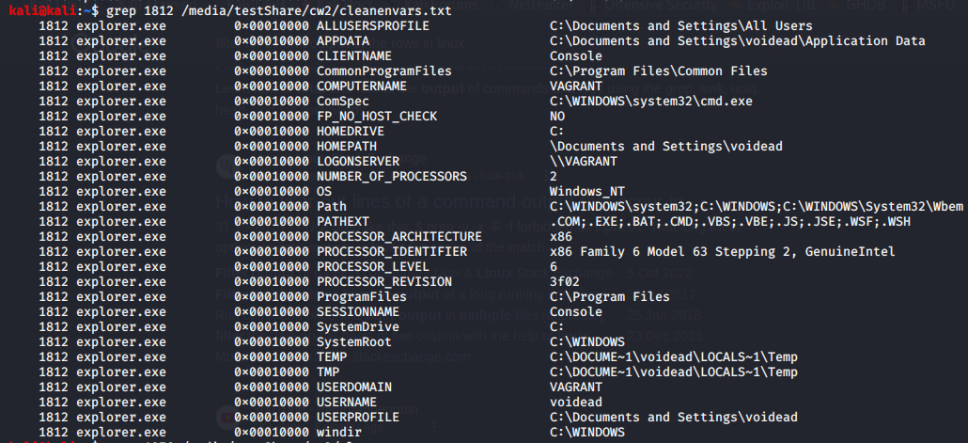

Object, Pools and Processes Image 51 - PID 1812 envars

Process 1812, explorer.exe, follows spoolsv.exe in both dumps & in both dumps the Parent PID is not visible, but the explorer has been launched by the user currently logged in here, voidead, just like in the infected dump & all other variables bear the similar variables excluding CPU info and computer name.

|  |  |
| --- | --- |
| Command | Output |
| grep 1976 /media/testshare/cw2/cleanenvars.txt | grep for the number 1976, to get the environmental variables associated to PID 1976 |

Object, pools and processes Table 55 - grep for PID 1976 envars

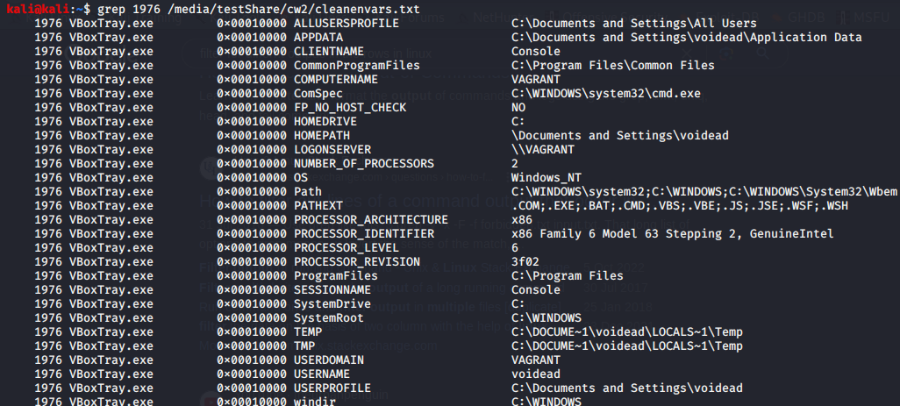

Object, Pools and Processes Image 52 - PID 1976 envars

Process 1976, VBoxTray.exe is another VirtualBox related process which “provides additional functionality to the guest operating system, enhancing its performance and improving the management of the virtual machine” (file.net, 2024)

|  |  |
| --- | --- |
| Command | Output |
| grep 180 /media/testshare/cw2/cleanenvars.txt | grep for the number 180, to get the environmental variables associated to PID 180 |

Object, pools and processes Table 56 - grep for PID 180 envars

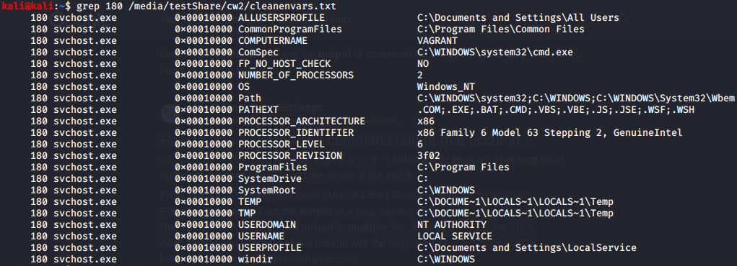

Object, Pools and Processes Image 53 - PID 180 envars

Process 180, svchost.exe, is where the two different dumps stop their similarities between processes. This instance of svchost is triggered by localservice whereas in the infected dump the process adjacent is reader_sl.exe or Process 1640. Process 180 is triggered by Local service/NT AUTHORITY which is a “predefined local account used by the service control manager” (Microsoft, 2021)”.

|  |  |
| --- | --- |
| Command | Output |
| grep 244 /media/testshare/cw2/cleanenvars.txt | grep for the number 244, to get the environmental variables associated to PID 244 |

Object, pools and processes Table 57 - Grep for PID 244

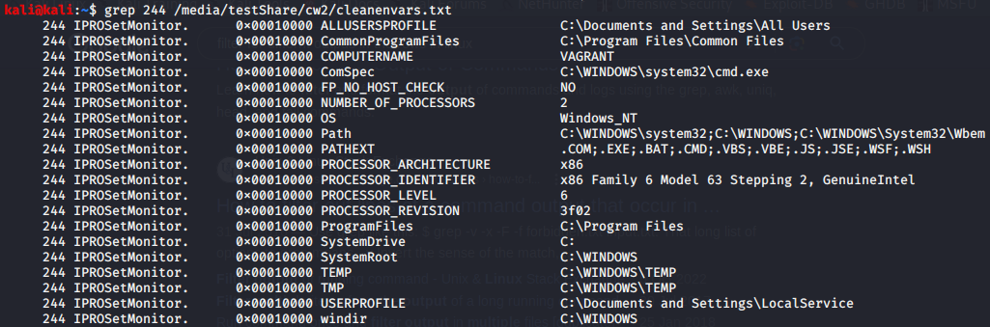

Object, Pools and Processes Image 54 - PID 244 envars

Process 244, IOPROSetMonitor.exe, Is “associated with hard-wired Ethernet LAN connections” (file.net, 2024) and the process “starts running in the background as soon as Windows boots up, (although its start can be delayed under 'Services')” (file.net, 2024). It utilises the LocalService privileges that is a “predefined local account used by the service control manager” (Microsoft, 2021)”.

|  |  |
| --- | --- |
| Command | Output |
| grep 756 /media/testshare/cw2/cleanenvars.txt | grep for the number 756, to get the environmental variables associated to PID 756 |

Object, pools and processes Table 58 - grep for PID 756 envars

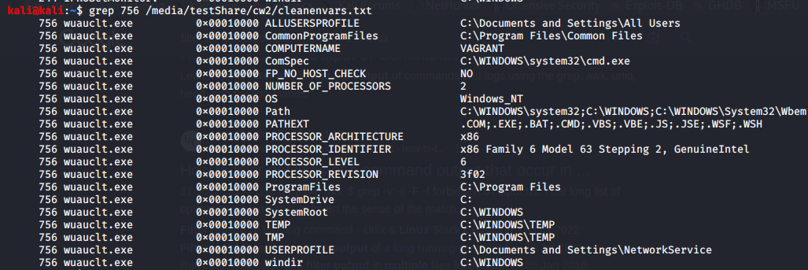

Object, Pools and Processes Image 55 - PID 756 envars

Process 756, wuauclt.exe, is used to search for and perform updates to the computer system, so it utilises the NetworkService user profile to make these connections. It can also be seen in the infected dump being triggered hinting that it is a normal process that has been triggered. It also has a PPID that points to a svchost.exe process just like in the infected dump.

|  |  |
| --- | --- |
| Command | Output |
| grep 1712 /media/testshare/cw2/cleanenvars.txt | grep for the number 1712, to get the environmental variables associated to PID 1712 |

Object, pools and processes Table 59 - grep for PID 1712

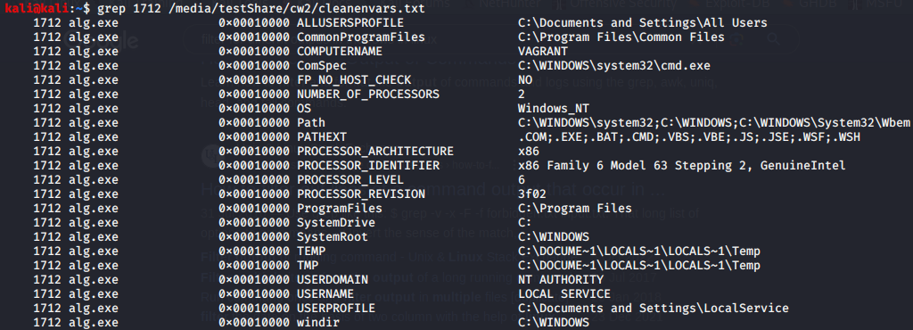

Object, Pools and Processes Image 56 - PID 1712 envars

Process 1712, alg.exe, is another process that is seen in the infected dump and Is triggered by the PPID of services in each dump. It “is responsible for providing support for Internet Connection Sharing (ICS) and the Windows Firewall” (S.Picili, 2023) & is imperative for normal computer functionality.

|  |  |
| --- | --- |
| Command | Output |
| grep 340 /media/testshare/cw2/cleanenvars.txt | grep for the number 340, to get the environmental variables associated to PID 340 |

Object, pools and processes Table 60 - grep for PID 340 envars

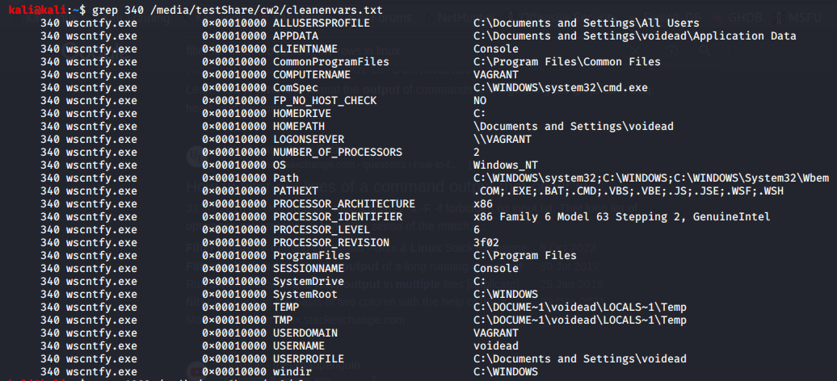

Object, Pools and Processes Image 57 - PID 340 envars

Process 340, wscntfy.exe, is “a feature that monitors the security status of your system and alerts you of any potential issues” (S.Picili, 2023). It appears to have been triggered by the same instance of svchost that triggered wuauclt.exe.

|  |  |
| --- | --- |
| Command | Output |
| grep 1068 /media/testshare/cw2/cleanenvars.txt | grep for the number 1068, to get the environmental variables associated to PID 1068 |

Object, pools and processes Table 61 - grep for PID 1068 envars

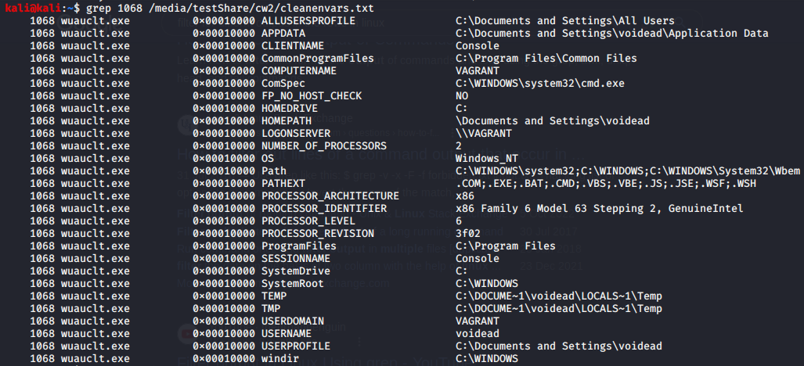

Object, Pools and Processes Image 58 - PID 1068 envars

Process 756, wuauclt.exe, is used to search for and perform updates to the computer system, so it utilises the NetworkService user profile to make these connections. It can also be seen in the infected dump being triggered hinting that it is a normal process that has been triggered. It also has a PPID that points to a svchost.exe process just like in the infected dump.

|  |  |
| --- | --- |
| Command | Output |
| grep 1492 /media/testshare/cw2/cleanenvars.txt | grep for the number 1068, to get the environmental variables associated to PID 1068 |

Object, pools and processes Table 62 - grep for PID 1492

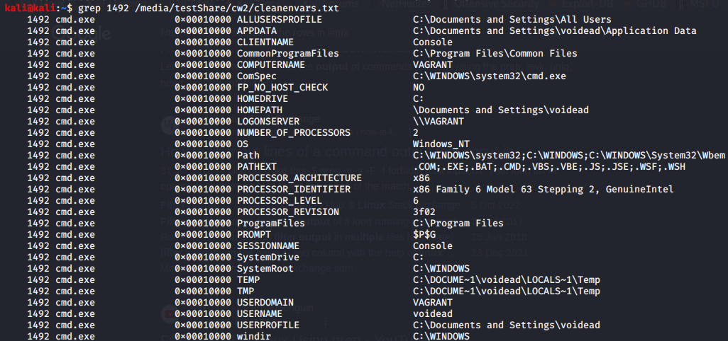

Object, Pools and Processes Image 59 - PID 1492 envars

Process 1492, cmd.exe, is the command line utility provided by windows XP, it has been triggered by voidead This process was triggered by the end user.

|  |  |
| --- | --- |
| Command | Output |
| grep 604 /media/testshare/cw2/cleanenvars.txt | grep for the number 604, to get the environmental variables associated to PID 604 |

Object, pools and processes Table 63 - grep for PID 604 envars

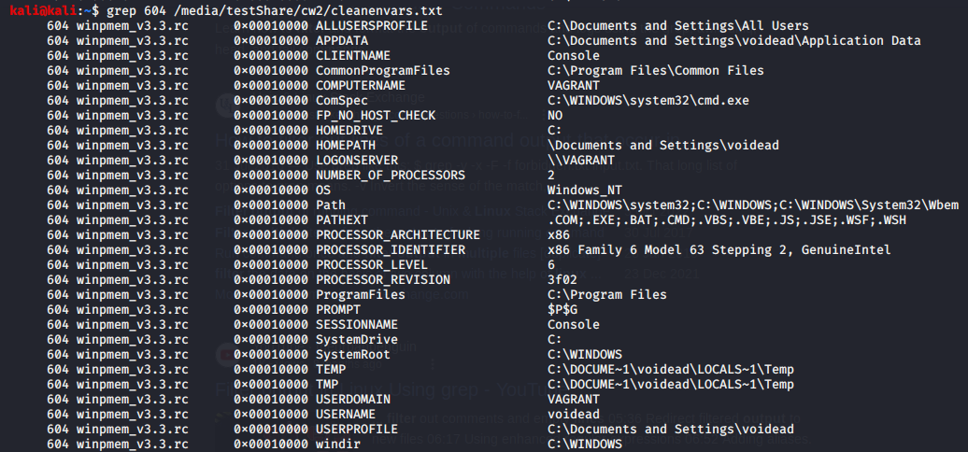

Object, Pools and Processes Image 60 - PID 604 envars

Process 604, winpmem_v3.3.rc is used to create an image of the clean memory so it would make sense for it to be the last process that is displayed by pslist.

First there must be distinctions made between the different processes to be able to accurately discover which user is reataining which process bears the username. The output is as seen in Object, pools and processes Table 64.

|  |  |
| --- | --- |
| User | Process |
| Voidead | Explorer.exe: PID 1812  VBoxTray.exe: PID 1976  Wscntfy.exe: PID 340  Wuauclt.exe: PID 1068  Cmd.exe: PID 1492  Winpmem_v3.3.rc: PID 604 |
| Network Service | Svchost.exe: PID 996  Svchost.exe: PID 1240 |
| Local service | Svchost.exe: PID 1344  Svchost.exe: PID 180  Alg.exe: PID 1712 |

Object, pools and processes Table 64 - Enumerated processes and their associated users

To confirm these findings for the user voidead, the plugin getsids can be used.

|  |  |
| --- | --- |
| Command | Output |
| volatility -f /media/testShare/windowsclean.raw --profile=WinXPSP3x86 getsids > ../cw2/cleangetsids.txt | Gets the security identifiers then put them into the text file |
| cat ../cw2/cleangetsids.txt | grep voidead | Grep for user voidead in the getsids file |

Object, pools and processes Table 65 - getsids plugin and output with a grep for voidead

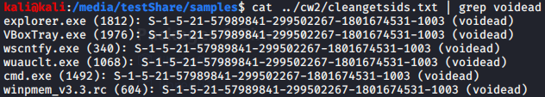

Object, Pools and Processes Image 61 - user Voideds associated processes

As can be seen above from figure Object, pools and processes Image 61 there are 6 just like the ones identified in the envars confirming that the envars and getsids are working & the results are validating each other.

Another way to check what privileges the end user may have been to extract the SAM registry file and then once the file is extracted to allow for the file to be utilized by a tool named sampasswd. To execute this, use the command in Object, pools and processes Table 66 to make a folder and get the dump for the infected dump.

|  |  |
| --- | --- |
| Command | Output |
| Mkdir dumpedCleanRegistry | Make the directory |
| volatility --plugins=/media/testShare/plugins -f /media/testShare/cw2_Machine4Infected.dump --profile=WinXPSP3x86 dumpregistry --dump-dir dumpedRegistry/ | Dump the registry files to the specified directory |

Object, pools and processes Table 66 - creation of directory for the dumping of the registry and the dumpregistry plugin

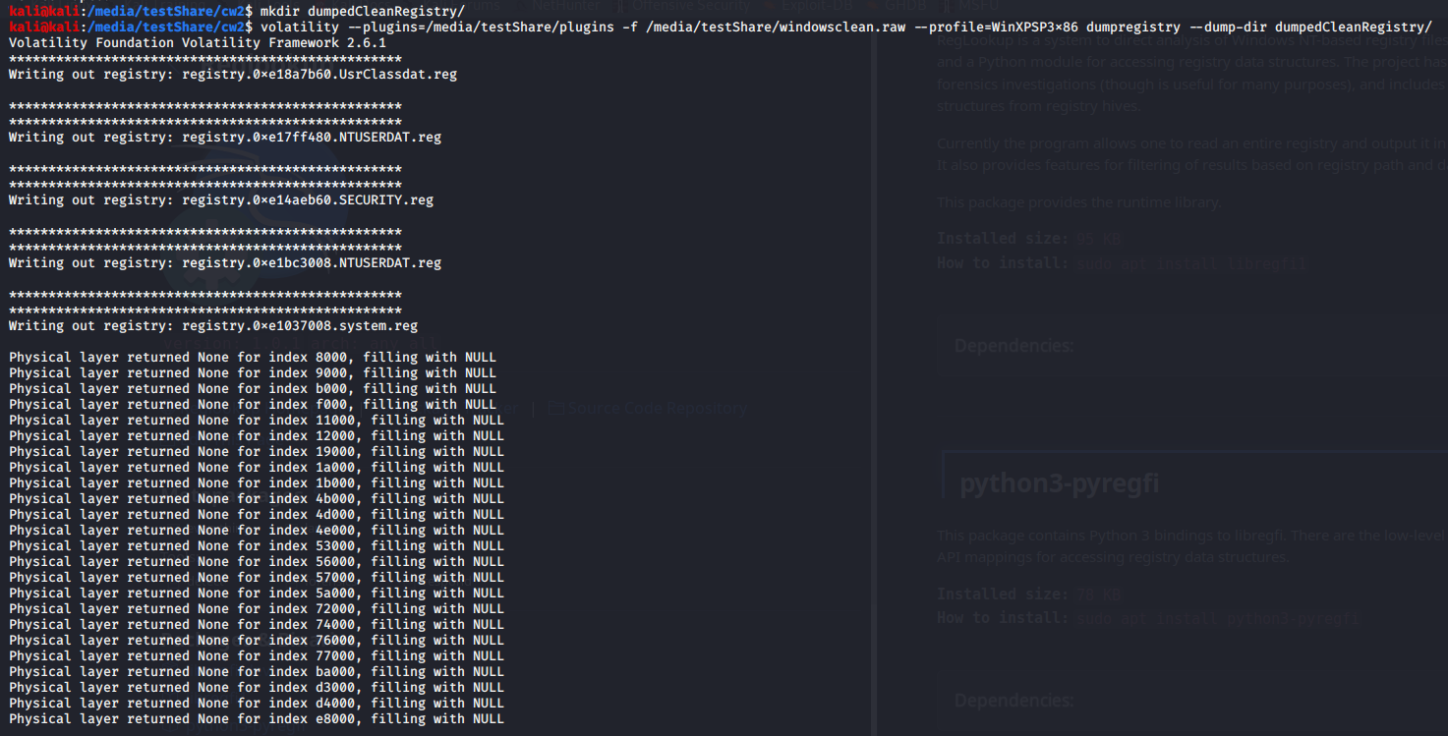

Object, Pools and Processes Image 62 - dumpregistry output

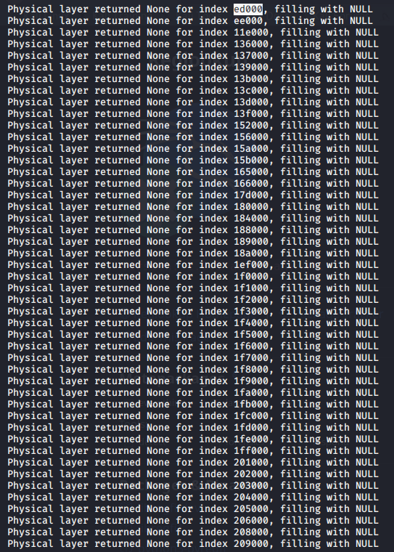

Object, Pools and Processes Image 63 - dumpregistry output continued

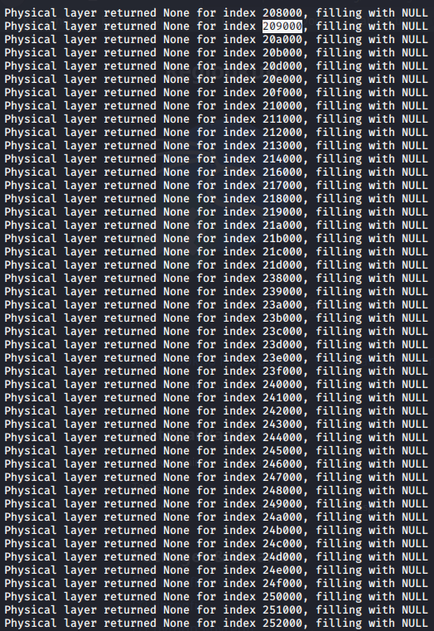

Object, Pools and Processes Image 64 - dumpregistry output continued

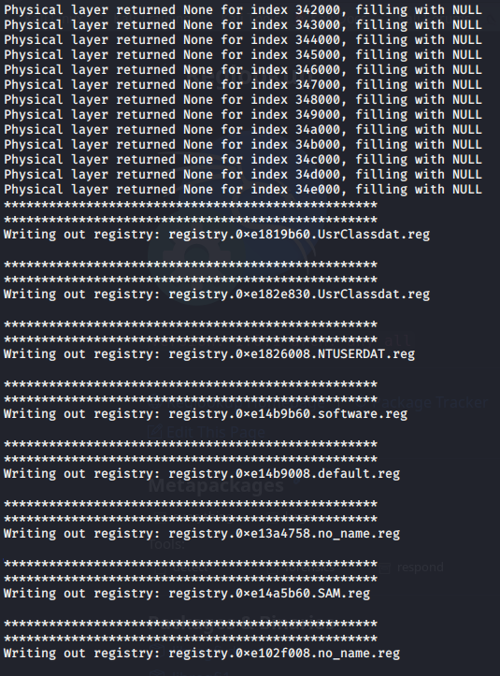

Object, Pools and Processes Image 65 - dump registry output continued

After this utilise sampasswd by using the command in figure Object, pools and processes Table 67.

|  |  |
| --- | --- |
| Command | Output |
| sampasswd -H -l registry.0xe1579e8.SAM.reg | Sampasswd is a linux tool that can be used to parse registry information. The switch -H gives “human readable output” (Linux Manuals, nd) and the -l that “Lists the users in the SAM” (Linux Manuals, nd). Here it is used on the clean dump and produces 5 different users confirming that there are two administrators in the dump. |

Object, pools and processes Table 67 - sampasswd command

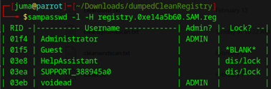

Object, Pools and Processes Image 66 - sampasswd output

As can be seen just above in figure Object, pools and processes Image 66 there are two administrators, One is Robert, and the other is the default administrator that can be found in any windows XP. This confirms the privileges assigned to the user voidead. This is the same as the infected dump.

## 4. In the provided memory dump, enumerate the enabled privileges for every process that is not a critical process of the system. Indicate whether these privileges are indicators of compromise or not and explain why. (10%) //

### Infected dump:

To answer the question, first the distinction between a critical and non-critical process must be made, One way to find out what process is critical or not is to open a windows machine, open task manager and then select the three dots at the top right corner then go into View -> Group by type.

The reason as to why this is an effective filter is because it enumerates the processes using a function that is called “IsProcessCritical” (R. Chen, 2018) & this function takes a “hard-coded list of specific processes” (R. Chen, 2018) and bases whether the process is critical or not based on that. Searching through this list will give an idea what is a critical process or not.

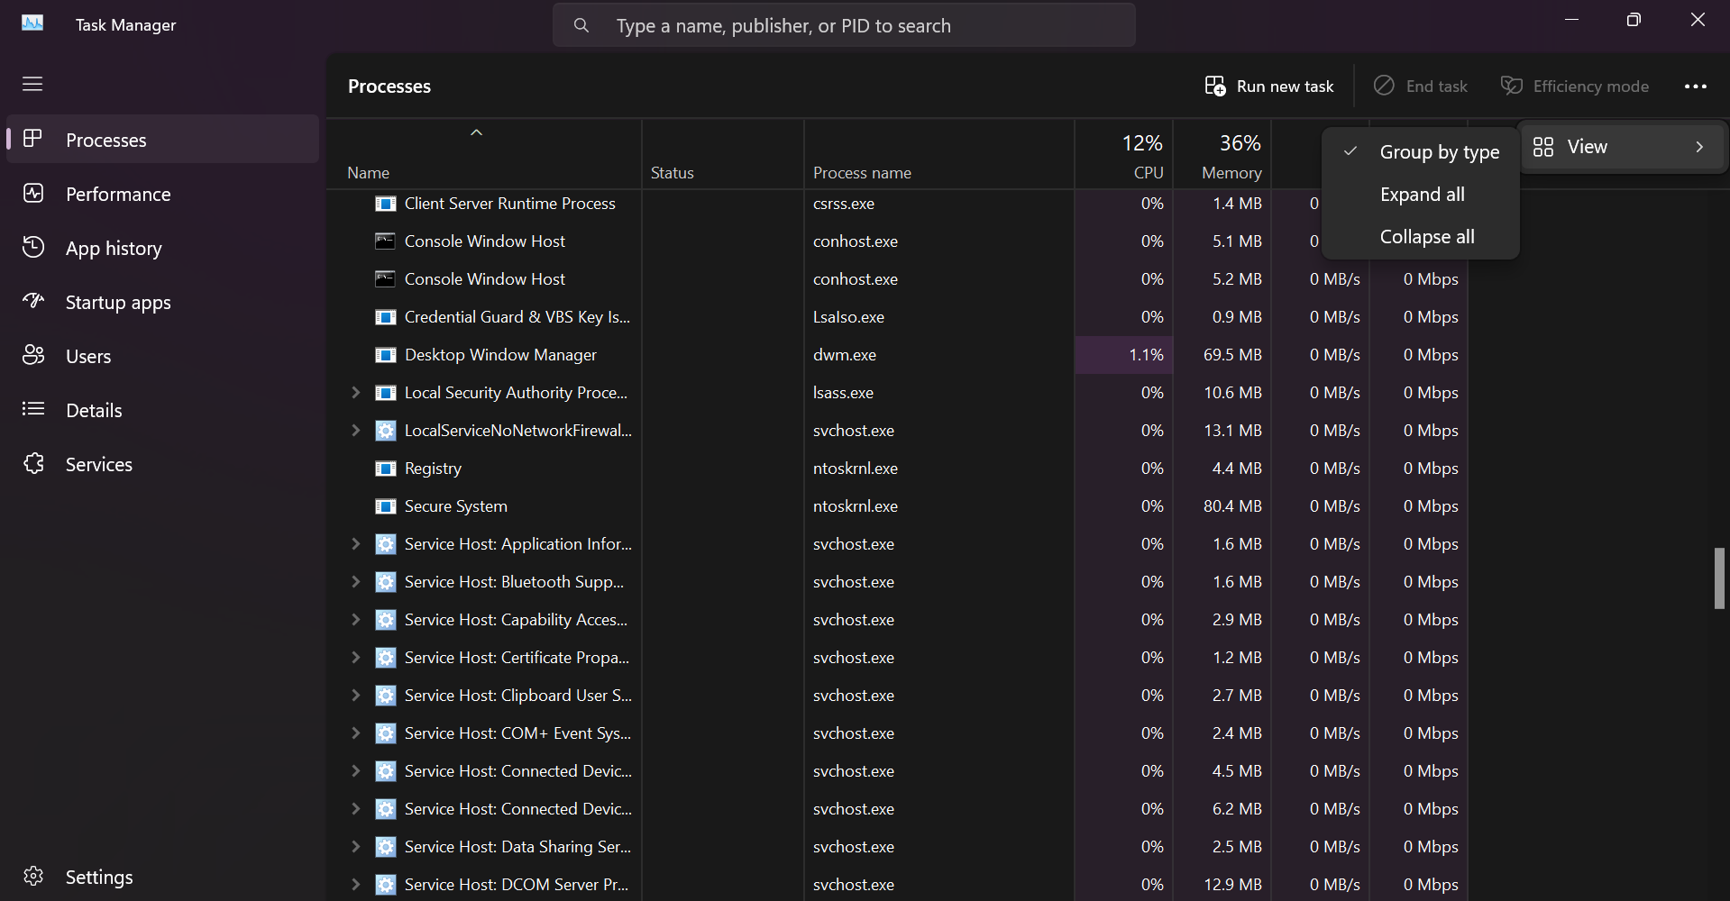

Object, Pools and Processes Image 67 - Task Manager

Then after this right click on name & select process name to help identify the relevant process associated with windows.

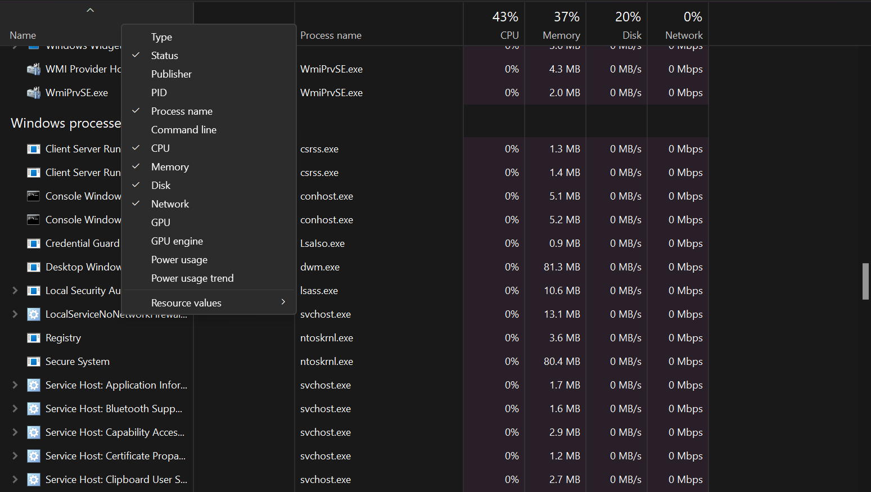

Object, Pools and Processes Image 68 - displaying how to add process name in task manager

Basing off this list, the processes that have been identified based on the pslist as not being critical are:

-Reader_sl.exe,

-wuauclt.exe,

-spoolsv.exe

-alg.exe

|  |  |
| --- | --- |
| Command | Output |
| volatility --plugins=/media/testShare/plugins -f /media/testShare/cw2_Machine4Infected.dump --profile=WinXPSP3x86 privs --output-file=privs.txt | Get the output of the privs plugin which will display the privileges then put it into the privs.txt file |

Privs uses the process derived from pslist to filter, unfortunately as there is a limited range of processes so only four will be used as lsass will need to be excluded. To get the privileges first run the plugin privs for volatility to carve out the privileges for the individual processes. Use the command in figure Object, pools and processes Table 68.

Object, pools and processes Table 68 - privs plugin



Object, Pools and Processes Image 69 - privs plugin output

The next step is to filter the processes that have been acquired. To filter the process, use the PID’s that were found above in the previous question as they already have users associated with them.

The output of privs displays 6 different columns as seen in Object, pools and processes Image 80 an explanation of these columns is in Object, pools and processes Table 69.

Object, Pools and Processes Image 70 - privs output

|  |  |
| --- | --- |
| **Column** | **Explanation** |
| PID | Process Identifier |
| Process | The process that the privileges are being shown for |
| Value | Value associated with the privilege |
| Privilege | The privilege associated with the process |
| Attributes | Attributes are of three types: Present, Enabled and Default. Present means that |
| Description | Describes what the privilege is capable of |

Object, pools and processes Table 69 - privs ouput explained

After this use grep to see the associated prvileges between the different users. As The different users processes have been identified already in the previous question. Some of the privileges needed to execute malware are as seen below so any time that they are assigned to a user that is not an administrator there should be suspicions raised as some can even alter driver data (data that goes between different pieces of hardware on the motherboard or alter the translation of the data from the motherboard).

* “SeImpersonatePrivilege
* SeAssignPrimaryPrivilege
* SeTcbPrivilege
* SeBackupPrivilege
* SeRestorePrivilege
* SeCreateTokenPrivilege
* SeLoadDriverPrivilege
* SeTakeOwnershipPrivilege
* SeDebugPrivilege” (dronesec, 2017)

|  |  |
| --- | --- |
| Command | Explanation |
| robert: awk '/SeImpersonatePrivilege/||/SeAssignPrimaryPrivilege/||/SeTcbPrivilege/||/SeBackupPrivilege/||/SeRestorePrivilege/||/SeCreateTokenPrivilege/||/SeLoadDriverPrivilege/||/SeTakeOwnershipPrivilege/||/SeDebugPrivilege/{print}' privs.txt | egrep "1588|1640" | awk for all the privileges associated with privilege escalation & then grep the PID’s associated with robert |

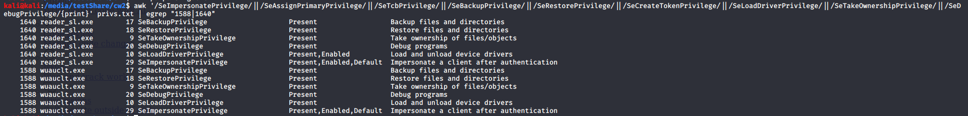Object, pools and processes Table 70 - awk for the different privilege escaltions between roberts PID

Object, Pools and Processes Image 71 - Output from the awk command

As can be seen in Object, Pools and processes Image 71, it appears that some of the processes launched by the user Robert bear the privileges that are commonly used by privilege escalation, in addition to this they bear the enabled attribute that would allow for the kernel to recognise that the privilege displayed is belonging to a user that is administrative in nature.

|  |  |
| --- | --- |
| Command | Explanation |
| LocalService: awk '/SeImpersonatePrivilege/||/SeAssignPrimaryPrivilege/||/SeTcbPrivilege/||/SeBackupPrivilege/||/SeRestorePrivilege/||/SeCreateTokenPrivilege/||/SeLoadDriverPrivilege/||/SeTakeOwnershipPrivilege/||/SeDebugPrivilege/{print}' privs.txt | egrep "1512|788" | awk for all the privileges associated with privilege escalation & then grep the PID’s associated with LocalService |

Object, pools and processes Table 71 - awk for the Localservice related PID's for Privileges



Object, Pools and Processes Image 72 - output from the aforementioned command.

LocalService also has a few privileges that can be used for escalation.

|  |  |
| --- | --- |
| Command | Output |
| Network Service: awk '/SeImpersonatePrivilege/||/SeAssignPrimaryPrivilege/||/SeTcbPrivilege/||/SeBackupPrivilege/||/SeRestorePrivilege/||/SeCreateTokenPrivilege/||/SeLoadDriverPrivilege/||/SeTakeOwnershipPrivilege/||/SeDebugPrivilege/{print}' privs.txt | egrep "1056|1136" | awk for all the privileges associated with privilege escalation & then grep the PID’s associated with LocalService |

Object, pools and processes Table 72 - awk for privileges associated with Network Service



Object, Pools and Processes Image 73 - awk output

Network service also has quite a few

### Clean Dump:

Utilising the same method in the infected dump to distinguish as between critical and non-critical processes are enumerated the conclusion of the 5 non-criticial processes are:

-VBoxService.exe

-Spoolsv.exe

-VBoxTray.exe

-IOProSetMonitor

-winpmem_v3.3.rc

|  |  |
| --- | --- |
| Command | Output |
| Voidead: awk '/SeImpersonatePrivilege/||/SeAssignPrimaryPrivilege/||/SeTcbPrivilege/||/SeBackupPrivilege/||/SeRestorePrivilege/||/SeCreateTokenPrivilege/||/SeLoadDriverPrivilege/||/SeTakeOwnershipPrivilege/||/SeDebugPrivilege/{print}' cleanprivs.txt | egrep "1976|340|1068|1492|604" | awk for all the privileges associated with privilege escalation & then grep the PID’s associated with voidead |

Object, pools and processes Table 73 - awk for voidead privileges.

Object, Pools and Processes Image 74 - awk output

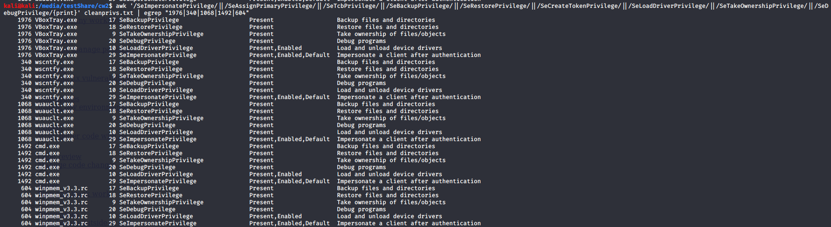

As can be seen from Object, Pools and Processes Image 74 voidead has quite a few privileges that can be used for privilege escalation hinting that they may be an administrative account.

|  |  |
| --- | --- |
| Command | Explanation |
| Local Service: awk '/SeImpersonatePrivilege/||/SeAssignPrimaryPrivilege/||/SeTcbPrivilege/||/SeBackupPrivilege/||/SeRestorePrivilege/||/SeCreateTokenPrivilege/||/SeLoadDriverPrivilege/||/SeTakeOwnershipPrivilege/||/SeDebugPrivilege/{print}' cleanprivs.txt | egrep "1712" | Awk for processes associated with the localservice account |

Object, pools and processes Table 74 - awk for Local Service privileges

Object, Pools and Processes Image 75 - awk output

There is only one privilege that can be utilised which is the SeImpersonatePrivilege. Comparing the number of privileges executed from the different dumps the clean dump has a much better implementation of separation of processes as there is much less room for privileges to be escalated. There are also less privileges that have not been enabled by default hinting that there has been less alteration between the different processes in the clean dump compared to in the infected.

## 5. Enumerate the handles and symbolic links of each memory dump and describe 5 handles and symbolic links that are different. How many handles and symbolic links are in total in both memory dumps? (10%) / /

To answer this question the first thing to be done is to understand handles and symbolic links, A handle is an opening, it can be to a file or to a process, handles can have varying levels of access such as read or write or both.

A symbolic link is a link that is used in order to point to a specific path, a basic example of one is a shortcut that when you click it takes you to where the executable is as opposed to typing in the full path or looking for the executable.

### Infected Dump:

To answer this question, the first thing that must be done is to have the plugin handles run on the infected dump. This can be done with the command in Object, pools and processes Table 75.

|  |  |
| --- | --- |
| Command | Explanation |
| volatility --plugins=/media/testShare/plugins -f /media/testShare/cw2_Machine4Infected.dump --profile=WinXPSP3x86 handles > cw2/handles.txt | Get the handles for the different [rocesses and see what files they access. |

Object, pools and processes Table 75 - command for handles plugin

catting the output of handles gives us 6 columns.

|  |  |
| --- | --- |
| Command | Ouput |
| cat handles.txt | Display the entire file. |

Object, pools and processes Table 76 - cat handles.txt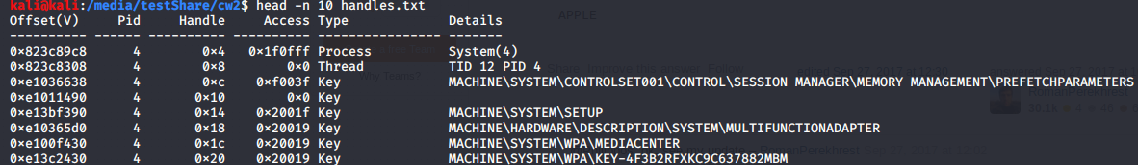

Object, Pools and Processes Image 76 - output of handles.txt

A brief explanation of these columns can be seen in Object, pools and processes Table 77.

|  |  |
| --- | --- |
| Column | Explanation |
| Offset | Offset where the handle was found |
| PID | Process ID associated with the handle |
| Handle | What number handle it is (appears to be incremented in 4 times table represented in hexadecimal) |
| Access | Where the starting point of access is (PID + Access) |
| Type | Type of handle it is |
| Details | What the handle may be doing |

Object, pools and processes Table 77 - explanation of handles.txt

After running handles on the memory dump, the next step is to filter out the different types to enumerate them. To achieve this the command in Object, pools and processes Table 78 was used.

|  |  |
| --- | --- |
| Command | Explanation |
| sort -uk 5 cw2/handles.txt | awk '{print $5}' | sort -u | Sort by fifth column, print 5th column then sort for unique entries |

Object, pools and processes Table 78 - command to filter for the different handle types

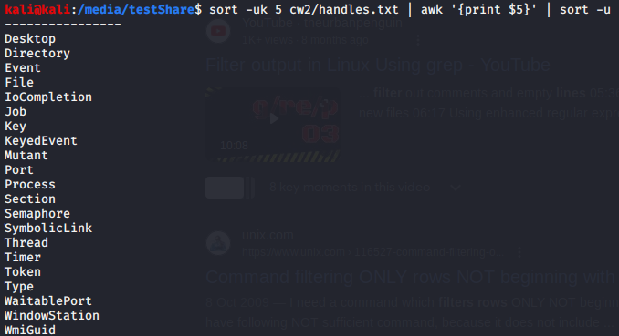

Object, Pools and Processes Image 77 - commands output

As can be seen by figure Object, pools and processes Image 77 once filtered there are only a few types of files so to enumerate these a grep will be performed for every type.

|  |  |
| --- | --- |
| Command | Explanation |
| awk 'NR>2 && / Desktop / {print}' cw2/handles.txt | wc -l && awk 'NR>2 && / Directory / {print}' cw2/handles.txt | wc -l && awk 'NR>2 && / Event / {print}' cw2/handles.txt | wc -l && awk 'NR>2 && / File / {print}' cw2/handles.txt | wc -l && awk 'NR>2 && / IoCompletion / {print}' cw2/handles.txt | wc -l && awk 'NR>2 && / Job / {print}' cw2/handles.txt | wc -l && awk 'NR>2 && / Key / {print}' cw2/handles.txt | wc -l && awk 'NR>2 && / KeyedEvent / {print}' cw2/handles.txt | wc -l && awk 'NR>2 && / Mutant / {print}' cw2/handles.txt | wc -l && awk 'NR>2 && / Port / {print}' cw2/handles.txt | wc -l && awk 'NR>2 && / Process / {print}' cw2/handles.txt | wc -l && awk 'NR>2 && / Section / {print}' cw2/handles.txt | wc -l && awk 'NR>2 && / Semaphore / {print}' cw2/handles.txt | wc -l && awk 'NR>2 && / SymbolicLink / {print}' cw2/handles.txt | wc -l && awk 'NR>2 && / Thread / {print}' cw2/handles.txt | wc -l && awk 'NR>2 && / Timer / {print}' cw2/handles.txt | wc -l && awk 'NR>2 && / Token / {print}' cw2/handles.txt | wc -l && awk 'NR>2 && / Type / {print}' cw2/handles.txt | wc -l && awk 'NR>2 && / WaitablePort / {print}' cw2/handles.txt | wc -l && awk 'NR>2 && / WindowStation / {print}' cw2/handles.txt | wc -l && awk 'NR>2 && / WmiGuid / {print}' cw2/handles.txt | wc -l | Awk from row number two as the first two rows are volatility descriptive rows. After this and && statement is used to get the string being filtered for, spaces are used to prevent false positives from being represented in the output. |

Object, pools and processes Table 79 - grep chain to get the enumerate the different handles

As can be seen in Object, pools, and Processes Image 78 the respective amounts of the different instances of each handle is displayed.

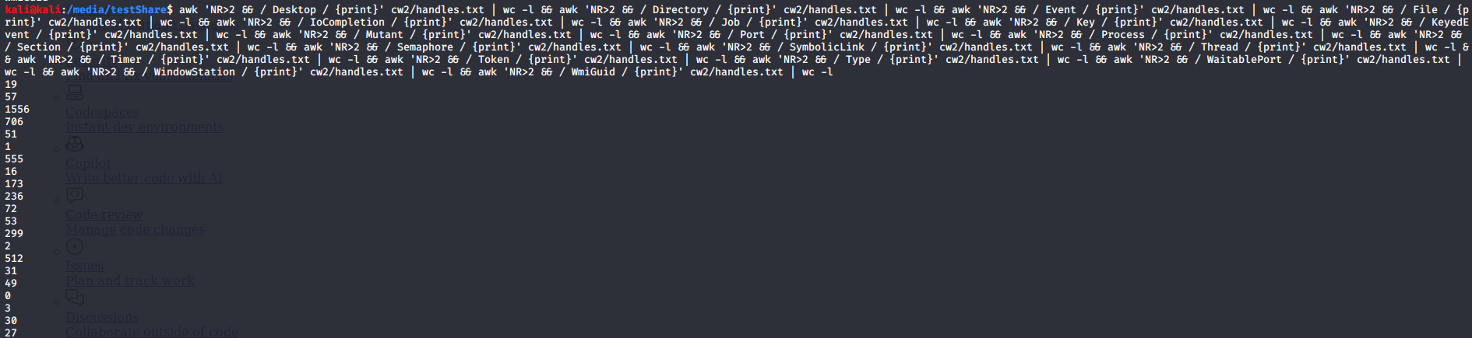

Object, Pools and Processes Image 78 - output of the command

* Desktop 19
* Directory 57
* Event 1556
* File 706
* IoCompletion 51
* Job 1
* Key 555
* KeyedEvent 16
* Mutant 173
* Port 236
* Process 72
* Section 53
* Semaphore 299
* SymbolicLink 2
* Thread 512
* Timer 31
* Token 49
* Type 0
* WaitablePort 3
* WindowStation 30
* WmiGuid 27

To describe 5 different handles there must be 5 different handles displayed. This can be achieved by displaying some of the different handles, one way to achieve this is by using the command below in Objects, pools and processes Table 80.

|  |  |
| --- | --- |
| Command | Output |
| awk '/Type/||/WaitablePort/||/WindowStation/||/Timer/ {print}' cw2/handles.txt | sort -u | sort -nrk 5 | head -n 29 | Awk for different types then a sort for unique entries, display the first 29 |

Object, pools and processes Table 80 - awk for 5 different handles

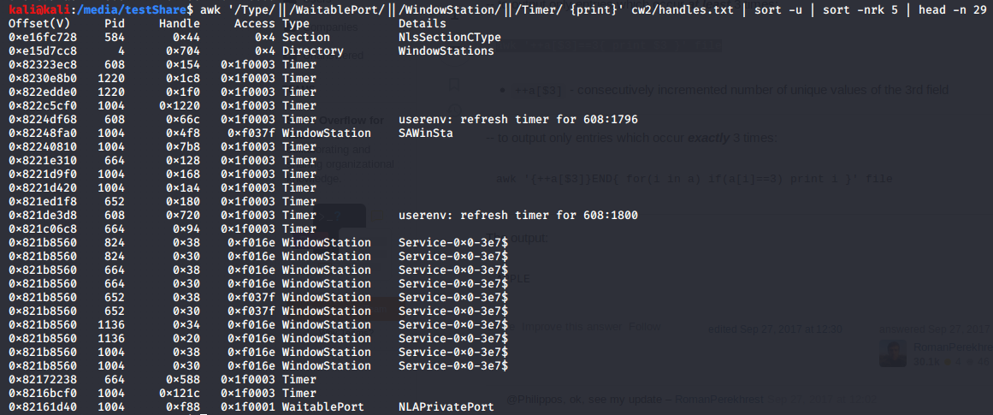

Object, Pools and Processes Image 79 - output

The handles that will be explained are as highlighted in red in Objects, pools and processes Image 79.

|  |  |
| --- | --- |
| Handle | Explanation |
| 0x44 | This is a handle into process 584, it bears a type of section which means that it is simply addressing a section in memory & that section is of a CType, C is a programming language that is used in windows computer system so a process using a CType is expected. |
| 0x704 | This is a handle into the directory WindowsStations, it has a PID of 4 which is the system as seen in figure … This handle is likely being used by the system to display to relay windows station information to the end user, but it could also be modifying the WindowsStations as well to make it display false information. |
| 0x4f8 | This is a handle into the process1004, it appears to bear the type of a windows station and bears the details of SAWInsta, which is a non-interactive station object. |
| 0x720 | This is a handle into process 608, and it is a timer that in the userenviroment refreshes at the specified time of 1800 for the process 608 as seen in 608:1800. This could be to reinstate the process or to schedule the process to be restarted. |
| 0xf88 | This is a handle into process 1004, it is a Waitable Port which is a port leveraged to “wait for a completion packet to be queued to the I/O completion port, rather than waiting directly for the asynchronous I/O to complete” (Microsoft, 2022) it appears to be using NLAprivatePort (Network Level Awareness) that allows for the communication to be identified as sensitive. |

Object, pools and processes Table 81 - Selected handles and their explanations

The next step to answer the question is to gain 5 symbolic links. This can be achieved by using the volatility plugin seen in Objects, pools and processes Table 82

|  |  |
| --- | --- |
| Command | Output |
| volatility --plugins=/media/testShare/plugins -f /media/testShare/cw2_Machine4Infected.dump --profile=WinXPSP3x86 symlinkscan --output-file=symlinkscan.txt | Plugin to get the symbolic links then these links are sent to the symlinkscan.txt file |

Object, pools and processes Table 82 - command to get symbolic links

After this filter to get 5 of the symbolic links associated with the memory dump using the command in figure Objects, pools and processes Table 83.

|  |  |
| --- | --- |
| Command | Output |
| Head -n 7 symlinkscan.txt | Display the first 7 rows of symlinkscan.txt |

Object, pools and processes Table 83 - getting the first 7 entries of the command

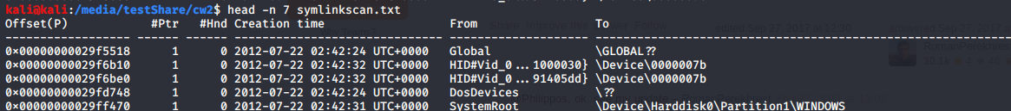

Object, Pools and Processes Image 80 - command output

From the output of symlinksscan there are 6 Columns to its output. The columns are explained in figure Objects, pools and processes Table 84.

|  |  |
| --- | --- |
| Column | Explanation |
| Offset | The offset where the symbolic link can be found |
| #Ptr | Number of pointers |
| #Hnd | Number of Handles |
| Creation time | When the Symbolic link was created |
| From | Where the symbolic link has been triggered from |
| To | Where the symbolic link has ended up |

Object, pools and processes Table 84 - output of the command explained

In Objects, pools and processes Image 93there are 5 symbolic links. A description of these symbolic links is as seen in Objects, pools and processes Table 85.

|  |  |
| --- | --- |
| Symbolic Link offset | Explanation of the symbolic link |
| 0x00000000029f5518 | The first symbolic link has only 1 pointer, no Handles & was created at 2012/07/22 (YYYY/MM/DD), it is from a global device, and it ended up at a global device but the absolute path is not shown. |
| 0x00000000029f6b10 | The second symbolic link appears to be from a foreign device, device 0000007b |
| 0x00000000029f6be0 | The second symbolic link appears to be from a foreign device, device 0000007b |
| 0x00000000029fd748 | The third device appears to be from DosDevices which “is virtual name that maps to a place in the NT/Windows Object Manager's” (P.Sangha, 2010) and ended up at an unknown place. |
| 0x00000000029ff470 | The last Symbolic link was from SystemRoot & ended up at \Device\Harddisk0\Partitions\WINDOWS |

Object, pools and processes Table 85 - symbolic links explained

### Clean dump:

|  |  |
| --- | --- |
| Command | Output |
| volatility --plugins=/media/testShare/plugins -f /media/testShare/windowsclean.dump --profile=WinXPSP3x86 handles > cw2/cleanhandles.txt | Handles plugin to enumerate the handles in the clean dump then output to cleanhandles.txt |

Object, pools and processes Table 86 - command to get the handels

After this filter to be able to get the different types of

|  |  |
| --- | --- |
| Command | Output |
| sort -uk 5 cw2/handles.txt | awk '{print $5}' | sort -u | Sort by column 5 then print the 5th column, finally sort the 5th column for unique entries |

Object, pools and processes Table 87 - sorting of the handles

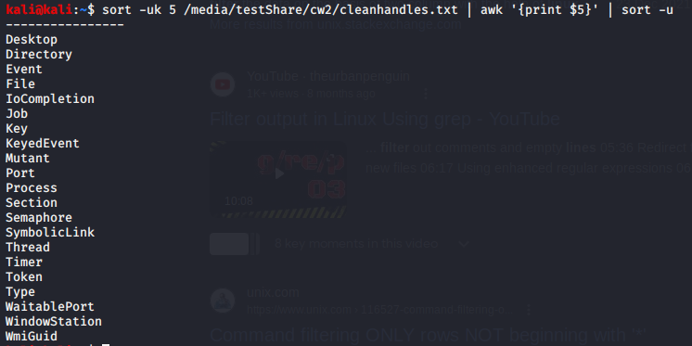After Filtering use these filters to count the different types by utilising the command in Objects, pools and processes Table 88.

Object, Pools and Processes Image 81 - command output

|  |  |
| --- | --- |
| Command | Output |
| awk 'NR>2 && / Desktop /' /media/testShare/cw2/cleanhandles.txt | wc -l && awk 'NR>2 && / Directory /' /media/testShare/cw2/cleanhandles.txt | wc -l && awk 'NR>2 && / Event /' /media/testShare/cw2/cleanhandles.txt | wc -l && awk 'NR>2 && / File /' /media/testShare/cw2/cleanhandles.txt | wc -l && awk 'NR>2 && / IoCompletion /' /media/testShare/cw2/cleanhandles.txt | wc -l && awk 'NR>2 && / Job /' /media/testShare/cw2/cleanhandles.txt | wc -l && awk 'NR>2 && / Key /' /media/testShare/cw2/cleanhandles.txt | wc -l && awk 'NR>2 && / KeyedEvent /' /media/testShare/cw2/cleanhandles.txt | wc -l && awk 'NR>2 && / Mutant /' /media/testShare/cw2/cleanhandles.txt | wc -l && awk 'NR>2 && / Port /' /media/testShare/cw2/cleanhandles.txt | wc -l && awk 'NR>2 && / Process /' /media/testShare/cw2/cleanhandles.txt | wc -l && awk 'NR>2 && / Section /' /media/testShare/cw2/cleanhandles.txt | wc -l && awk 'NR>2 && / Semaphore /' /media/testShare/cw2/cleanhandles.txt | wc -l && awk 'NR>2 && / SymbolicLink /' /media/testShare/cw2/cleanhandles.txt | wc -l && awk 'NR>2 && / Thread /' /media/testShare/cw2/cleanhandles.txt | wc -l && awk 'NR>2 && / Timer /' /media/testShare/cw2/cleanhandles.txt | wc -l && awk 'NR>2 && / Token /' /media/testShare/cw2/cleanhandles.txt | wc -l && awk 'NR>2 && / Type /' /media/testShare/cw2/cleanhandles.txt | wc -l && awk 'NR>2 && / WaitablePort /' /media/testShare/cw2/cleanhandles.txt | wc -l && awk 'NR>2 && / WindowStation /' /media/testShare/cw2/cleanhandles.txt | wc -l && awk 'NR>2 && / WmiGuid /' /media/testShare/cw2/cleanhandles.txt | wc -l | Awk chain to get the handles in the clean dump just like in the infected dump |

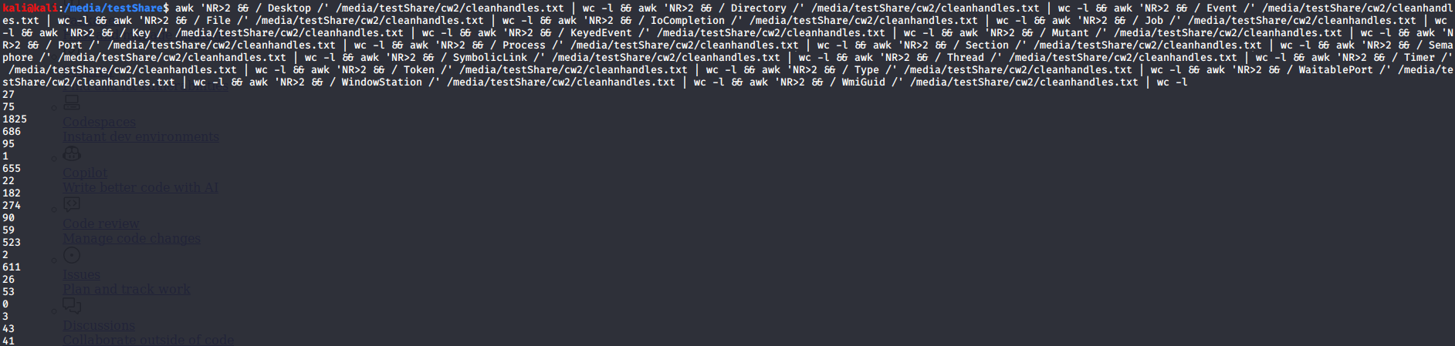Object, pools and processes Table 88 - filter for the different handles

Object, Pools and Processes Image 82 - command output

The output that is produced aligned with the different

* Desktop 27
* Desktop 75
* Event 1825
* File 686
* IoCompletion 95
* Job 1
* Key 655
* KeyedEvent 22
* Mutant 182
* Port 274
* Process 90
* Section 59
* Sephamore 523
* SymbolicLink 2
* Thread 611
* Timer 26
* Token 53
* Type 0
* WaitablePort 3
* WindowStation 43
* WmiGuid 41

To get the symbolic links for the clean dump use the command in Object, Pools and Processes Table 89.

|  |  |
| --- | --- |
| Command | Output |
| volatility --plugins=/media/testShare/plugins -f /media/testShare/windowsclean.raw --profile=WinXPSP3x86 symlinkscan --output-file=cleansymlinkscan.txt | Get the symbolic links then output them into a text file. |

Object, pools and processes Table 89 - command to get symbolic links



Object, Pools and Processes Image 83 - command output

After this display 5 different symbolic links is using the command in Object, Pools and Processes Table 90.

|  |  |
| --- | --- |
| Command | Output |
| Head -n 7 symlinkscan.txt | Get first 7 rows of output of the symlinkscan.txt file |

Object, pools and processes Table 90 - command to get the first 7 entries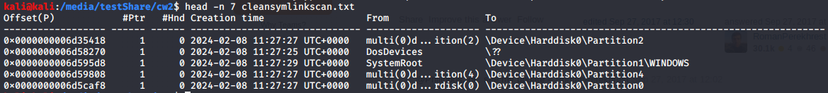

Object, Pools and Processes Image 84 - command output

The output is explained in Object, Pools and Processes Table 91.

|  |  |
| --- | --- |
| Symbolic link | Explanation |
| 0x0000000006d35418 | This symbolic link has 1 pointer and no handles, It was created on 2024/02/08 and appears to be from a disk 0 partition 2. It ends up pointing to disk 0 partition2. |
| 0x0000000006d58270 | This symbolic link has 1 pointer and no handles, It was created 2024/02/08 & It is a DosDevice and where it as ended up is an unknown location just like in the infected dump |
| 0x0000000006d595d8 | This symbolic link has 1 pointer and no handles, it was created at 2024/02/08 and it is from the SytemRoot and it points to the WINDOWS directory in partition 1 of disk 0 |
| 0x0000000006d59808 | This symbolic link has 1 pointer and no handles, was created on 2024/02/08 is from disk 0 partition 4 and points to partition 4 |
| 0x0000000006d5caf8 | This symbolic link has 1 pointer and no handles, was created on 2024/02/08 is from disk 0 partition 0 and points to partition 0 |

Object, pools and processes Table 91 - explanation of the differnet symbolic links

## 6. Choose 5 processes that are not critical processes of the system and use the volatility shell to create a short script that identify their associated DLLs. Provide the Python code and explain it. (10%) /

To begin this answer first plugins with similar outputs must be considered. One plugin that could potentially fit the bill is dlldump. Dlldump is utilised to “extract a DLL from a process's memory space and dump it to disk for analysis” (gleeda, 2020). So, what can be done is that the code of this plugin can be modified to attain the results that would answer this question.

The first step is to navigate to the volatility folder then make a copy of the file and then move that copy to a plugins directory that volatility could point to. A command to do this is displayed in Object, Pools and Processes Table 92.

|  |  |
| --- | --- |
| Command | Output |
| cd volatility/volatility/plugins/ | Change directory |
| cp dlldump.py cwattempt.py | Make a copy of the file with a different name |
| mv cwattempt.py /media/testShare/plugins | Move the copy to the /media/testShare/plugins directory |

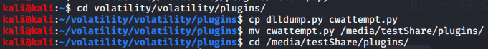Object, pools and processes Table 92 - direcotory creation and moving the file to the desired location

Object, Pools and Processes Image 85 - commands output

After this enter the file using vim using the command in Object, Pools and Processes Table 93 once you have entered the file use I to enter insert mode that will allow you to make the necessary changes to the file.

|  |  |
| --- | --- |
| Command | Output |
| Vim cwattempt.py | Open the cwattempt file in vim. |

Object, pools and processes Table 93 - command to open the file

Object, Pools and Processes Image 86 - command output

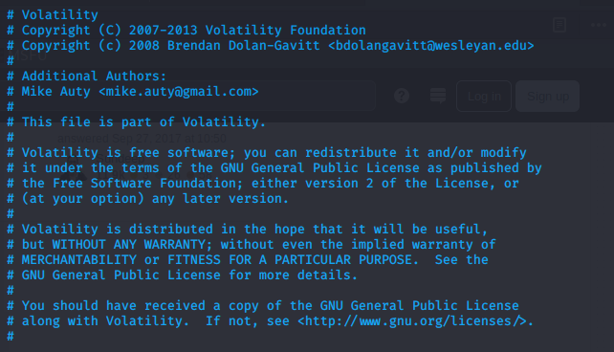First step is to delete all the comments along the top, everything shown in figure Object, Pools and Processes Image 87

Object, Pools and Processes Image 87 - comments to delete

The next step is to change the classname to CWAttempy & remove the dumpdir option,a side by side view highlighting the changes in red is seen in Object, Pools and Processes Image 88 below.

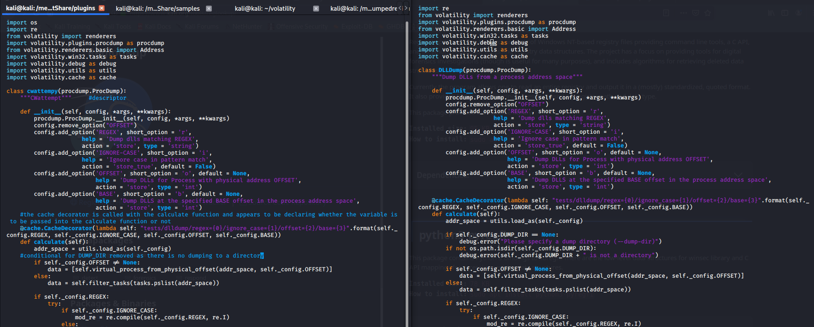

Object, Pools and Processes Image 88 - changes to make

The next set of changes is to remove the result field and change the array so that the generator does not produce the result and instead ends at the module name, ensure to close the data structure properly by reinserting the closing regular and square brackets.

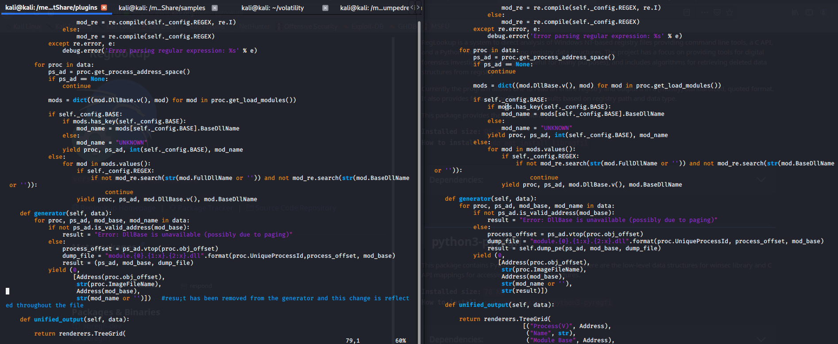

Object, Pools and Processes Image 89 - creation of cwattempy file continued

Finally make the changes highlighted in Object, Pools and Processes Image 90 initially remove the result representation from the bottom, remove the dumpdir conditional statement and add in a conditional statement to filter out any critical processes from being displayed. A side-by-side view can be seen in Object, Pools and Processes Image 90 with the necessary changes.

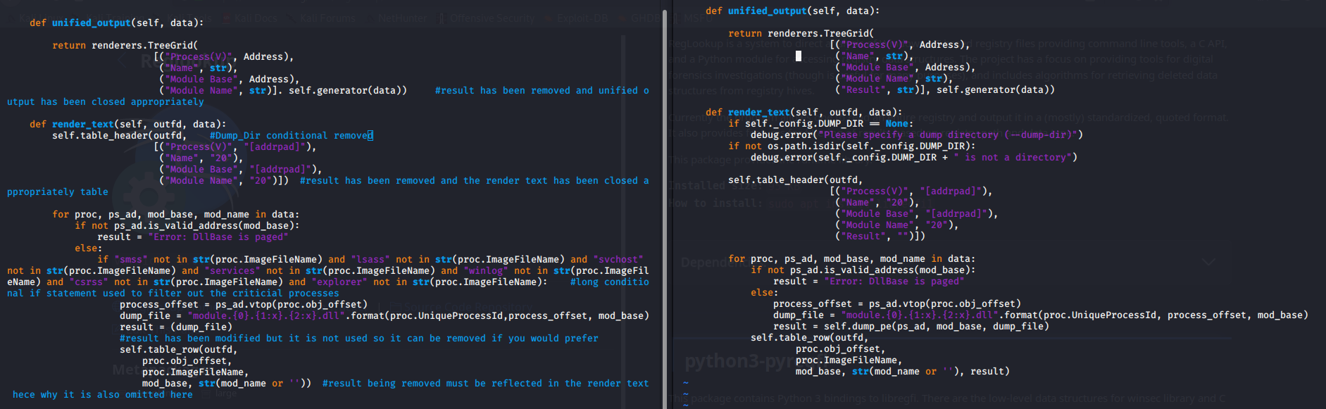

Object, Pools and Processes Image 90 - creation of cwattempy continued

Now run this code with the different memory dumps to compare the different outputs. Use the commands in Object, Pools and Processes Table 94 to achieve this.

|  |  |
| --- | --- |
| Command | Output |
| volatility --plugins=/media/testShare/plugins -f /media/testShare/cw2_Machine4Infected.dump --profile=WinXPSP3x86 cwattempy | Running the newly created plugin on the infected machine. |

Object, pools and processes Table 94 - running cwattempy

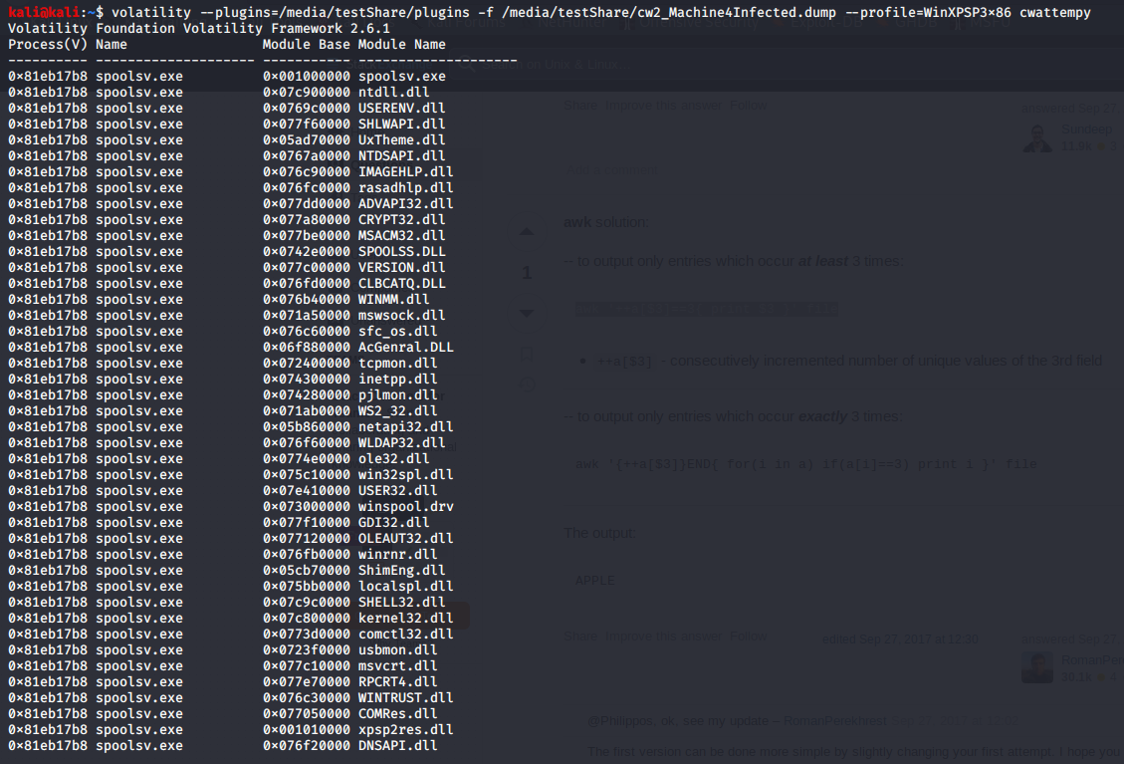

Object, Pools and Processes Image 91 - cwattempy output

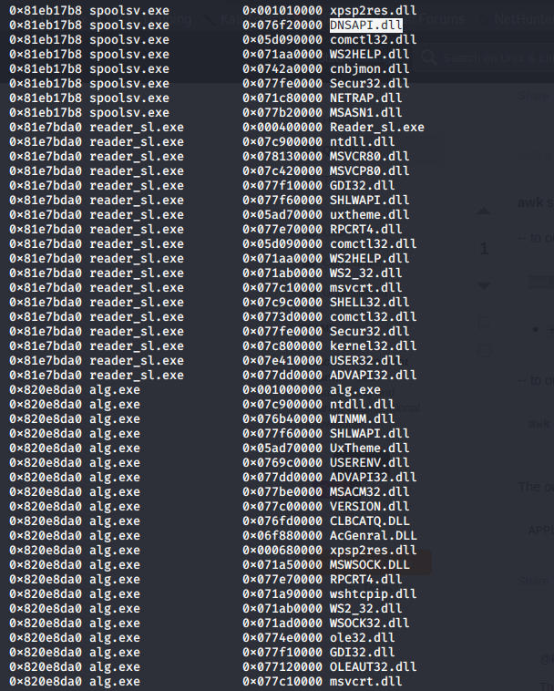

Object, Pools and Processes Image 92 - cwattempy output continued

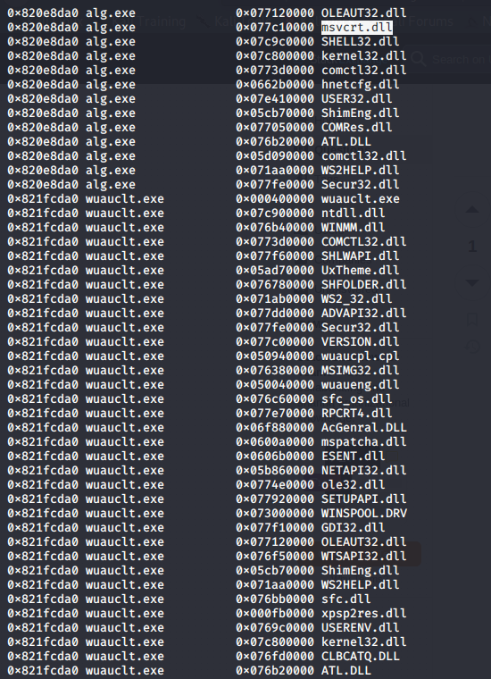

Object, Pools and Processes Image 93 - cw attempy output continued

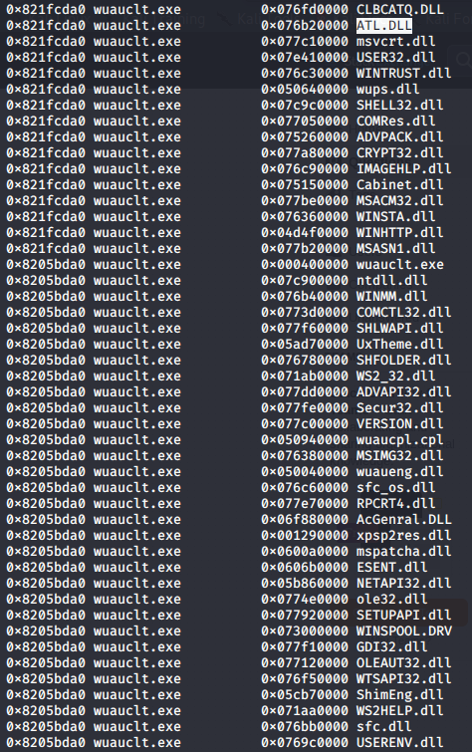

Object, Pools and Processes Image 94 - cwattempy output continued

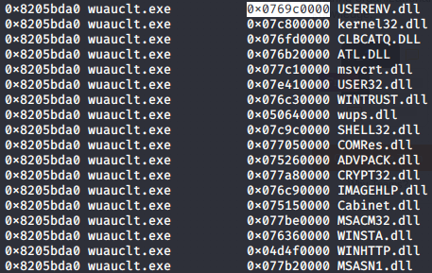

Object, Pools and Processes Image 95 - cw attempy output continued

There are four columns of output from the created plugin. Their explanations are in Object, Pools and Processes Table 95.

|  |  |
| --- | --- |
| Column | Explanation |
| Process | Process initialisation offset |
| Name | Name of the process |
| Module base | Where the DLL has been found |
| Module name | Name of the DLL being loaded in |

Object, pools and processes Table 95 - explanation of cwattempy output

Next the clean dump will be examined using the plugin.

|  |  |
| --- | --- |
| Command | Output |
| volatility --plugins=/media/testShare/plugins -f /media/testShare/windowsclean.raw --profile=WinXPSP3x86 cwattempy | Running the plugin on the clean dump. |

Object, pools and processes Table 96 - command to run cwattempy on the clean dump

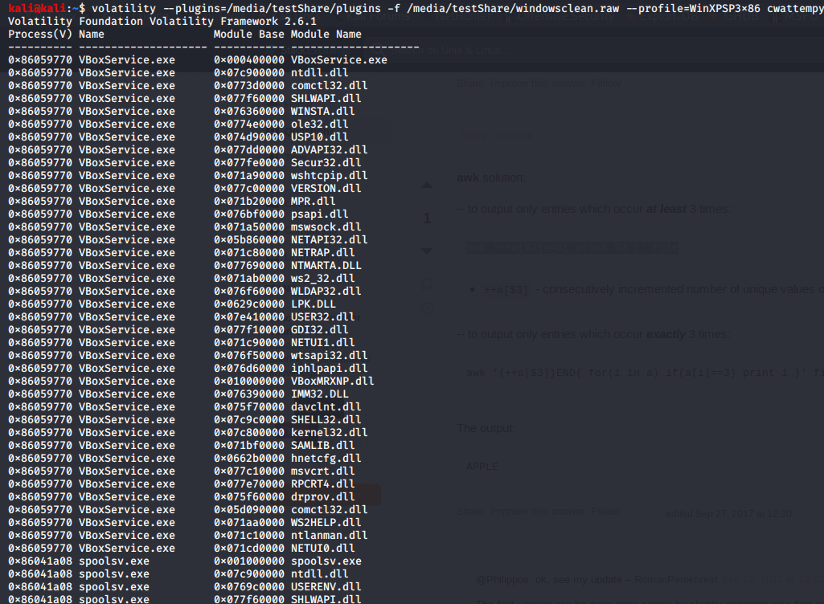

Object, Pools and Processes Image 96 - cw attempy output

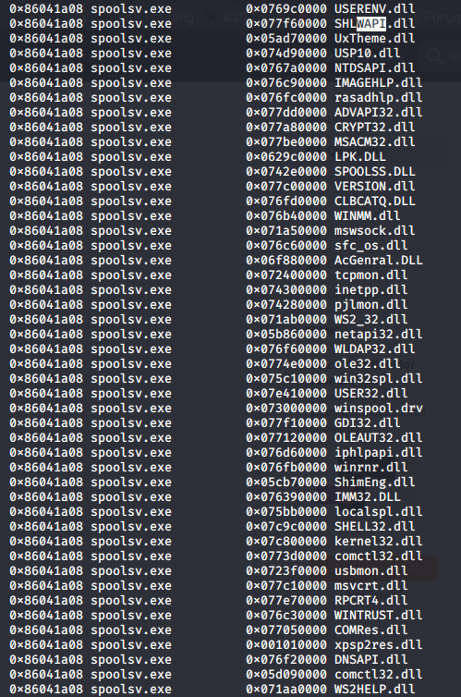

Object, Pools and Processes Image 97 - cwattempy output continued

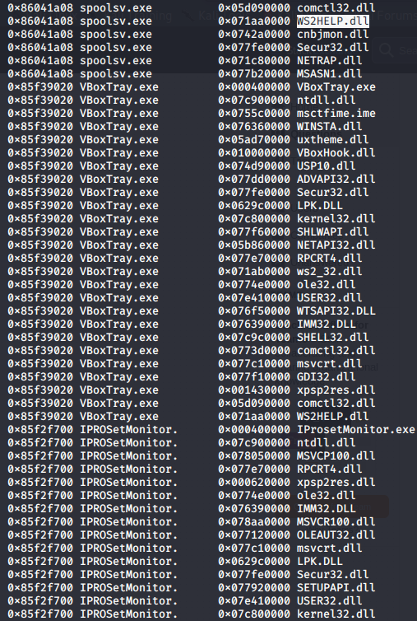

Object, Pools and Processes Image 98 - cwattempy output continued

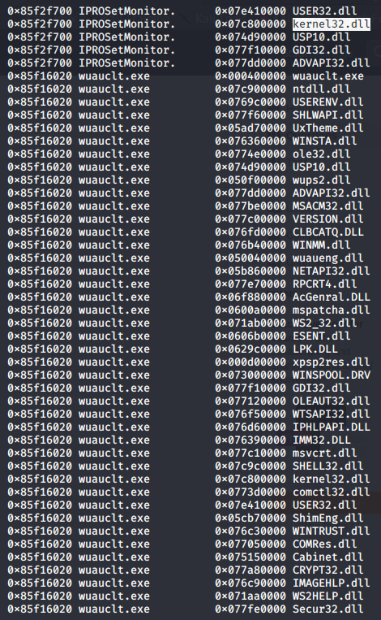

Object, Pools and Processes Image 99 - cwattempy output continued

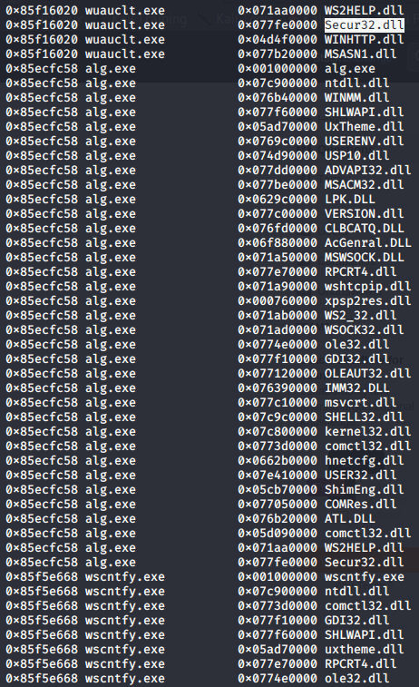

Object, Pools and Processes Image 100 - cwattempy output continued

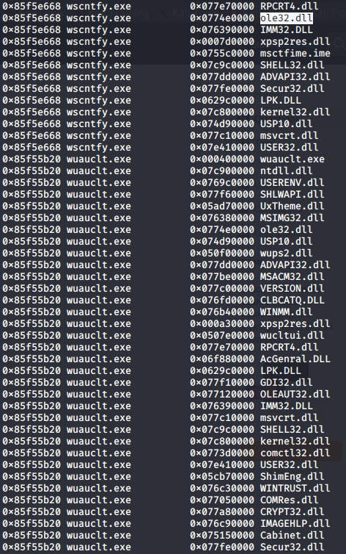

Object, Pools and Processes Image 101 - cwattempy output continued

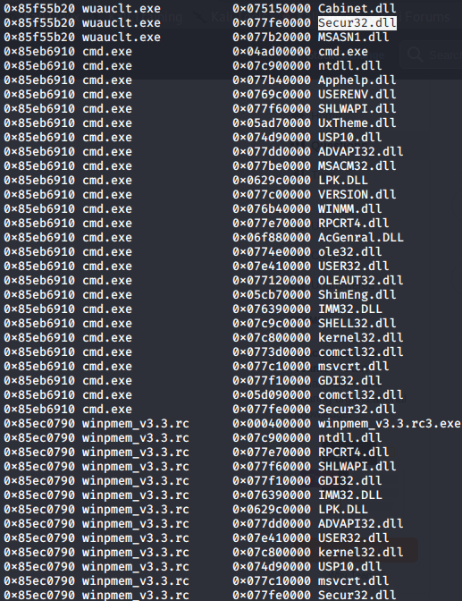

Object, Pools and Processes Image 102 - cwattempy output continued

As can be seen from the above figures the associated DLL’s from the output in addition to the output being put onto the screen as opposed to it being in output to directories as the dlldump plugin would have done.

## Bibliography:

Microsoft (2022) Handles and objects [online] Available at: <https://learn.microsoft.com/en-us/windows/win32/sysinfo/handles-and-objects> [Accessed 07/02/2024]

N.Gola (2022) What is SMSS.exe Process in Windows 11/10? Displaying High CPU usage? [online] Available at: <https://www.thewindowsclub.com/what-is-smss-exe-windows> [Accessed 12/02/2024]

Gleeda (2017) Command Reference [online] Available at: <https://github.com/volatilityfoundation/volatility/wiki/Command-Reference#privs> [Accessed 12/02/2024]

Gleeda (2020) Command Reference [online] Available at: <https://github.com/volatilityfoundation/volatility/wiki/Command-Reference#pslist> [Accessed 16/02/2024]

GNU (No Date) grep [online] Available at: <https://www.gnu.org/software/grep/> [Accessed: 12/02/24]

J.Laukkonen (2021) What Is Csrss.exe? [online] Available at: <https://www.lifewire.com/what-is-csrss-exe-4584354> [Accessed: 12/02/2024]

File.net (2024) What is Reader_sl.exe? [online] Available at: <https://www.file.net/process/reader_sl.exe.html> [Accessed: 12/02/2024]

Hale Ligh, M., Case, A. and Levy, J. (2014) The Art of Memory Forensics: Detecting Malware and Threats in Windows, Linux, and Mac Memory. Available at: <https://app.kortext.com/read/159539> [Accessed: 14 February 2024]

Dronesec (2017) Abusing Token Privileges For Windows Local Privilege Escalation [online] Available at: <https://foxglovesecurity.com/2017/08/25/abusing-token-privileges-for-windows-local-privilege-escalation/> [Accessed: 16/02/24]

AKASH GUPTA 6 (2023) cp command in Linux with examples [online] Available at: <https://www.geeksforgeeks.org/cp-command-linux-examples/> [Accessed 22/02/24]

Linuxize (2019) How to Use Nano, the Linux Command Line Text Editor [online] Available at: <https://linuxize.com/post/how-to-use-nano-text-editor/> [Accessed 20/02/24]

Vicodark (2014) 504ensicsLabs/DAMM [online] Available at: <https://github.com/504ensicsLabs/DAMM/blob/master/volatility/plugins/privileges.py> [Accessed 20/02/24]

Raghvendra3499 (2023) cd Command in Linux with Examples [online] Available at: <https://www.geeksforgeeks.org/cd-command-in-linux-with-examples/> [Accessed 22/02/24]

Dave Mckay (2022) How to Use the wc Command in Linux [online] Available at: <https://www.howtogeek.com/812441/wc-command-in-linux/> [Accessed 19/02/24]

C.Hoffman (2017) What Is "Spooler SubSystem App" (spoolsv.exe), and Why Is It Running on My PC? [online] Available at: <https://www.howtogeek.com/323332/what-is-spooler-subsystem-app-spoolsv.exe-and-why-is-it-running-on-my-pc/> [Accessed 12/02/2024]

D.Mckay (2023) How to Use the grep Command on Linux [online] Available at: https://www.howtogeek.com/496056/how-to-use-the-grep-command-on-linux/ [Accessed 13/02/24]

D. Mckay (2023) How to Use the awk Command on Linux [online] Available at: <https://www.howtogeek.com/562941/how-to-use-the-awk-command-on-linux/> [Accessed 22/02/2024]

High (2012) MoVP 1.2 Window Stations and Clipboard Malware [online] Available at: <https://volatility-labs.blogspot.com/2012/09/movp-12-window-stations-and-clipboard.html>

C. Tilbury (2011) Computer Forensic Artifacts: Windows 7 Shellbags [online] Available at: <https://www.sans.org/blog/computer-forensic-artifacts-windows-7-shellbags/> [Accessed 06/03/2024]

C. Marcho (2019) Getting Started with SVCHOST.EXE Troubleshooting [online] Available at: <https://techcommunity.microsoft.com/t5/ask-the-performance-team/getting-started-with-svchost-exe-troubleshooting/ba-p/372644> [Accessed 12/02/2024]

Microsoft (2021) LocalSystem Account [online] Available at: <https://learn.microsoft.com/en-us/windows/win32/services/localsystem-account> [Accessed 12/2/24]

Adobe (2022) AVConversionFromPDF (Conversion From PDF) [online] Available at: <https://www.adobe.com/devnet-docs/acrobatetk/tools/PrefRef/Windows/AVConversionFromPDF.html> [Accessed 07/03/2024]

Stelian Picili (2023) ALG.exe: What Is ALG.exe & Should You Remove It? [online] Available at: <https://malwaretips.com/blogs/alg-exe-what-is-alg-exe-should-you-remove-it/> [Accessed 12/02/2024]

Linux Manuals (nd) sampasswd [online] Available at: <https://www.systutorials.com/docs/linux/man/8-sampasswd/> [Accessed 17/02/24]

file.net (2024) What is VBoxService.exe? [online] Available at: <https://www.file.net/process/vboxservice.exe.html> [accessesd 13/02/24]

File.net (2024) What is VBoxTray.exe? [online] Available at: <https://www.file.net/process/vboxtray.exe.html> [Accessed 13/02/2024]

S.Picili (2023) Wscntfy.exe: What Is Wscntfy.exe & Should I Remove it? [online] Available at: <https://malwaretips.com/blogs/wscntfy-exe/> [Accessed 19/02/24]

R. Chen (2018) So what is a Windows “critical process” anyway? [online] Available at: <https://devblogs.microsoft.com/oldnewthing/20180216-00/?p=98035> [Accessed 14/02/2024]

Microsoft (2022) I/O Completion Ports [online] Available at: <https://learn.microsoft.com/en-us/windows/win32/fileio/i-o-completion-ports> [Accessed 17/02/2024]

P.Sangha (2010) What is the DosDevice? [online] Available at: <https://stackoverflow.com/questions/3580949/what-is-the-dosdevice> [Accessed 17/12/2024]